Top 10 Reasons why a Pregnant Woman NEEDS a Banana Split

- Calcium
  - Found in the ice cream, strawberries and peanuts
  - Needed for bone development

- Protein
  - Found in the ice cream and peanuts
  - Needed for healthy muscles, tissue, skin and hair

- Vitamin D
  - Found in the ice cream made with fortified milk
  - Needed for bone development

- Vitamin A
  - Found in ice cream and bananas
  - Needed for healthy eyes

- Vitamin C
  - Found in strawberries and pineapple
  - Needed for the immune system
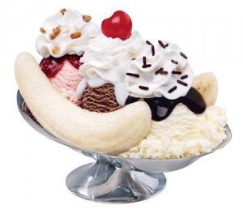
- Potassium
  - Found in bananas
  - May help prevent painful leg cramps
  - Regulates your heartbeat

- Iron
  - Found in the peanuts and strawberries
  - Needed for your blood

- Fiber
  - Found in pineapples, strawberries, bananas and peanuts
  - Needed for digestion

- Fat
  - Found in ice cream, cool whip and peanuts
  - Necessary for proper brain development and for absorption of Vitamin A, D, E, and K

- Flavor
  - Chocolate is a mood enhancer. It triggers the release of the “feeling good” brain chemical called serotonin.
  - Everybody needs a little self-indulgence occasionally!!

