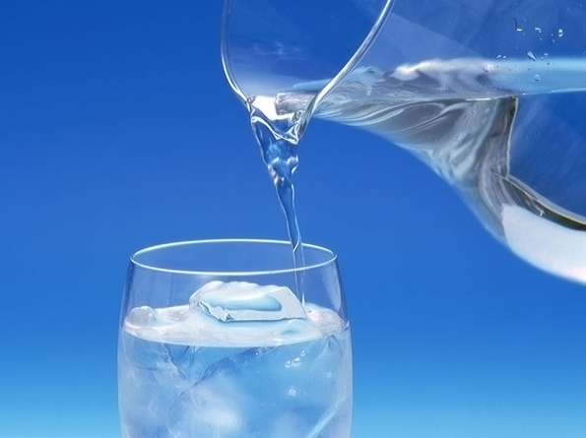
WATER, FRUITS AND VEGETABLES STUDY GUIDE
Name:__________________________________
Period:______
Water is Essential
- Water is the most ________________ of all the ______________ nutrients.
- The body ___________ survive long ____________ water.
- _________ is contained in most __________.
- Drink ________ instead of ___________ drinks.
Functions of Water
- Carries __________ soluble _____________.
- Carries __________ products through the _________.
- Regulates body _____________ through ________________.
- Prevents ___________________.
Dehydration
- Dehydration occurs from ______________________.
- Symptoms:
  - _____________________
  - _____________________
- ________________ should be a ___________________ color.
Prevention of Dehydration
- _________________ prevents ___________________.
- _______________ water and other fluids _____________________.
- Don’t wait to be ______________.
- Daily recommendation of water – _____________________

Sports/Fitness Activities
- For short duration exercise, _________________________:
  - _______________________ before, during and after exercise.
- For moderate to high intensity activities, lasting ______________________:
  - ______________________________ to help replace carbohydrate loss and _________________________.
- Drink according to ____________ during the day.
- Include _________________________.
- Drink _______________________ of water an hour before exercise.
- Continue drinking during exercise, up to _____________________ of fluid per hour (4-6 ounces every 15 minutes).
Nutrients found in fruits and vegetables

  - ____________________
  - ____________________
  - ____________________
  - ____________________
  - ____________________
  - ______________________
  - ______________________
  - ______________________
  - ______________________
Fruits and Vegetables
- Fruits and vegetables contain __________________________.
- Fruits and vegetables are low in ________________________________.
- ____________ your fruits and vegetables.
Destroying Nutrients
- __________________________
- __________________________
- __________________________

Oxidation
- Define: ______________________ that occurs when fresh fruits are _____________________________________
- This is caused by an __________________________________.
- Prevention:
    - Dipping or ______________ fruit with _____________ containing ____________________________.
    - _________________ the fruit until ______________________.
Eating Fruits and Vegetables
- Before eating your fruits and vegetables ___________ them to remove any ____________ and ________ that might remain on the _______.
- Choose ________ or cut-up _________ more often than fruit ________.
Preparation Methods
- _______________________________
- _______________________________
- _______________________________
- _______________________________
- _______________________________
- _______________________________
- _______________________________
Preparation Methods
- Cook in __________ rather than smaller ___________ when possible.
- Use a __________ amount of _____________.
- Cook only until ____________________.
- Save the cooking ___________ to use in _____________ or gravies for added ___________________.

Selecting Fresh Fruits and Vegetables
- _____________________________
- _____________________________
- _____________________________
- _____________________________
- _____________________________
- _____________________________
- _____________________________
Seasonal Fruits and Vegetables
- ________________________________
- ________________________________
- ________________________________
How Long Will They Last?
- __________ only what fruits and vegetables you will be able to _____________ and __________.
- They will last about ________________ in the __________________.
- Fruits will __________ and spoil __________ at ________ temperature.
Farm-to-Table Steps
  - ________________________
    - Use of good agricultural practices.
  - ________________________
    - Monitor at critical control points.
  - ________________________
    - Use clean vehicles and maintain the cold chain.
  - ________________________
    - Follow the food code guidelines
  - ________________________
    - Always follow the Four C’s of safety: ________________________
______________________________________________________

