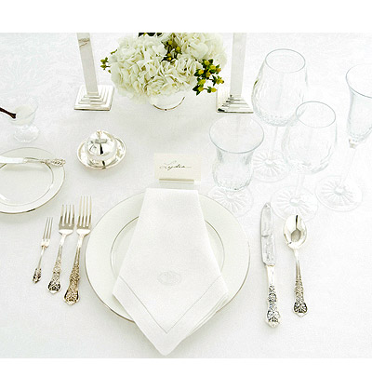
TABLE SETTING AND ETIQUETTE STUDY GUIDE
Name:________________________________
Period:_____

Proper Table Setting
- The _______________go on the ________________.
- The __________________________ go on the __________.
- The ______________ faces the _______________
- The _________________ go on the _________________.
- The ____________________ plate and __________plate go on the ______.

Formal Place Setting
- Fill out the attached formal place setting diagram.

American Style Eating
- ____________________ with a fork using the _____________ with the _________________pointing ____________________.
- Hold the ___________by the handle in the __________________.
- The _______________ toward the _______, but does not rest __the blade.
- Cut off __________________ at a time.
- _______________ a knife, fork or spoon in your _________.
- Place the ___________towards the ____________________________.
- Shift the _____________________________________.
- Hold the handle slightly between the _________________ and the ______________________.
- Bring food to your ________________.
- ______________________________ throughout the meal.

American Style – Resting Position
- Between bites or “_______________________”
  - The __________is placed on the ____________ of the plate in the ____ o’clock position.
  - ____________________________
  - The ________ placed on the __________ in the ____ o’clock position
  - __________ of the fork placed ______

American Style – I’m Finished
- When finished eating or “__________________” position
  - The _______________ are placed _____________ on the _________ of the plate in the _____o’clock position.
  - The ________on the ___________________.
  - The __________ on the ____________________________.

Continental Style Eating
- Hold the _________________________ as the American style.
- The only difference is you ______________________ with the knife or fork.
- The ________ will always stay in the ___________________.
- The ________ will always stay in the ___________________.
- You _______________ the knife or fork ____________ unless you are going to take a drink of beverage.
- You may ___________your forearms on the _________________________.

Continental Style – Resting Position
- Between bites or “______________________”
- The _______________________ in the ______________of the plate
- ________________ pointed __________.

Continental Style – I’m Finished
- “_____________________” position
- The ________________ are placed _______________ on the ________________ of the plate at the _____o’clock position.
- The _________________, tines are _____________
- The ___________________________, blade _____.

Napkin Placement
- The _________ should be placed in your ____________________________.
- When ____________ the table, place the napkin on the __________.
- When _____________, place the napkin to the ______________________.

Tipping
- A tip should be _______ of the bill

Cell Phone Use
- Cell phones should be on __________________________.
- ________________________ a call while dining.
- Check text messages ___________________.
  - That does not mean under the table when your company is not looking!!

Table Manners
- When choosing a piece of flatware __________________________.
- Chew with your _____________________________
- Avoid _________________________
- Cut only _______________________________________.
- _________________________ one piece at a time
- Avoid __________________________
- Don’t place __________________ on the table
- Pass the ____________________________.
- Don’t place _____________________________ back on the table

