Soft Skill #1: Communication
Communication Activity: You need to know how to communicate appropriately for different situations. The way you communicate at home with family is different than how you communicate with friends, or in a professional setting. Practice the way you would communicate BOTH verbally (what you would say and how you would say it) and non-verbally (facial expressions, behavior, body language). Discuss with your group what would be different when talking to friends, family or in a professional setting for each situation below and write your answers.
SITUATION #1: Saying hello or goodbye
Friends: ______________________________________________________________________________
Family: _______________________________________________________________________________
Professional: __________________________________________________________________________
SITUATION #2: Asking for help
Friends: ______________________________________________________________________________
Family: _______________________________________________________________________________
Professional: __________________________________________________________________________
SITUATION #3: Emailing or texting
Friends: ______________________________________________________________________________
Family: _______________________________________________________________________________
Professional: __________________________________________________________________________
SITUATION #4: Showing excitement
Friends: ______________________________________________________________________________
Family: _______________________________________________________________________________
Professional: __________________________________________________________________________
SITUATION #5: Bringing up a concern
Friends: ______________________________________________________________________________
Family: _______________________________________________________________________________
Professional: __________________________________________________________________________
Soft Skill #2: Enthusiasm & Attitude
Enthusiasm & Attitude Activity: Developing a positive attitude starts from learning to believe in one’s self. In order to believe in ourselves, we must first understand our personal strengths. In this activity, you will be considering and sharing your personal strengths. Each person in your group will take turns rolling the dice. Complete the following statement for the number you roll. Everyone else listens carefully, and then practices genuine enthusiasm and a positive attitude by responding to that person’s response. (Hey, that is great!, Wow! That’s awesome!, cheer, clap, etc.) Pass the dice to the next person. You must keep the dice going quickly. See how many times each person gets to roll the dice in your rotation. You should have everyone get to go at least 3 times.
If you roll a 1: “I am thankful for…”
If you roll a 2: “Other people compliment me on my ability to…”
If you roll a 3: “Something I would like other people to know about me is…”
If you roll a 4: “I feel really good about myself when…”
If you roll a 5: “I am proud of my ability to…”
If you roll a 6: “Something nice I recently did for someone else was…”

Soft Skill #3: Teamwork

Teamwork Activity: Choose one person in your group to be the leader. You can get 15 pieces of dry spaghetti (or 30 toothpicks) and 25 mini marshmallows. Your group has 5 minutes to create the tallest freestanding structure you can. Your team leader cannot touch anything. They only get to supervise and offer instructions. They cannot physically participate in this activity, but they MUST help and give directions. At the end of the time, you need to attach a piece of masking tape with your group name on it so we can compare your tower to the other groups.

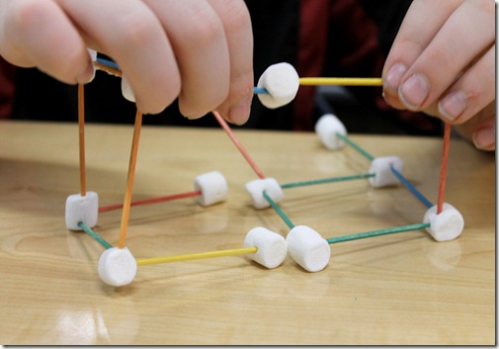

Picture Source: Luckeyfrog’s Lilypad: February 2013

Soft Skill #4: Networking
Networking Activity: Networking for the purpose of career development means talking with friends, family members, and acquaintances about your goals, your interests, and your dreams. In this activity you are going to see how many connections you can make with the other people in your group.
Each student will make their own Networking Card. Pick up one index card create a bulls-eye target with 3 levels. Label it “Skills”. In the center, write down 2 things you can do well enough to teach others. In the second ring, write down 2 things you would like to learn. In the final ring, write down 2 things you have trouble with.
Flip the index card over and create another bulls-eye target with 3 levels. Label it “People.” Ask those in your group who would be able to help you with your 2nd or 3rd level skills. If they can do it, personally, write their name in the bulls-eye center. If they can’t do it, but they know someone, personally, who can, write that person’s name in the 2nd ring of the bulls-eye. If they don’t have a personal connection with them, but they have heard of someone that could do that, write that person’s name in the 3rd level of the bulls-eye target.
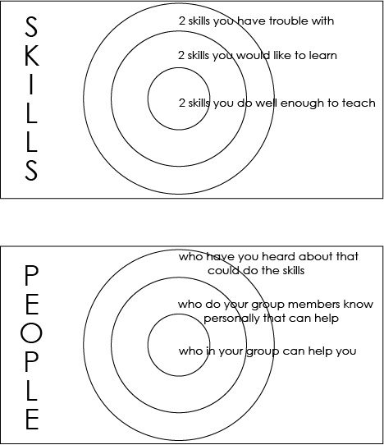
This is what networking is like. You make connections and find resources.

Soft Skill #5: Problem Solving & Critical Thinking

Problem Solving & Critical Thinking Activity: Tell Me About a Time When...
Each person in your group gets to choose a different question to describe from the list below. Use the STAR strategy below to guide you in answering the sample interview question, “Tell me about a time when you...”

Situation (or Task): Describe the situation that you were in or the task that needed to be accomplished. Be specific and give enough detail so that the interviewer understands. The situation could be from a previous job, a volunteer experience, school, or another relevant environment.
Action you took: Describe the action you took. Be sure to keep the focus on you! Even if you’re discussing a group project or effort, talk about what YOU did – not the efforts of the entire team. Don’t say what you might do or what you might have done. Say what you DID.
Results you achieved: What happened? How did the event end? What did you accomplish? What did you learn?

TELL ME ABOUT A TIME WHEN YOU:
...did not agree with a teacher or supervisor? How did you handle the situation?
...were able to use persuasion to successfully convince someone to see things your way.
...were faced with a stressful situation that demonstrated your coping skills.
...used good judgment and logic to solve a problem.
...set a goal and were able to meet or achieve it.
...had to conform to a policy with which you did not agree.
...had too many things to do and were required to prioritize your tasks.
... were able to successfully deal with another person even when that individual may not have
personally liked you (or vice versa).
...tried to accomplish something and failed.
...had to deal with a very upset customer or co-worker.
...you motivated others.

Soft Skill #6: Professionalism

Increasing Professionalism Activity: Discuss the following story about Justin with your group and give him some tips for being more professional on the job.

1. Justin is a stock clerk at the local grocery store. Justin does only what he is told to do, no more and no less.
Question: Does Justin have a good attitude toward work? Why or why not?

2. One day, one of Justin’s co-workers knocked over a product display. Boxes were scattered all over the floor. At the time, Justin was working close by. He ignored the scattered boxes and left his workstation to tell others what had happened.
Question: If you were the co-worker who knocked over the display, what would you have said to Justin?

3. Later the same day, Justin was stocking shelves. The item he was stocking belonged in another part of the store. A co-worker trying to help Justin told him he was making a mistake. Justin insisted he was right and started an argument.
Question: Was it right for Justin to argue with his co-worker? What could Justin have done differently?

4. Before Justin went home that night, he overheard a personal conversation between two co-workers and the supervisor. The next morning, Justin told everyone what he had heard. The entire grocery store was soon talking about what Justin told them.
Question: Was Justin correct in discussing what he had overheard? Explain.

5. When Justin’s supervisor found out what had happened, she called Justin into her office for a conference.
Question: What do you think was said to Justin?
Question: If you were one of Justin’s co-workers, what advice would you give to him?
Question: If you were Justin’s supervisor, what could you do to help him become a better employee?

