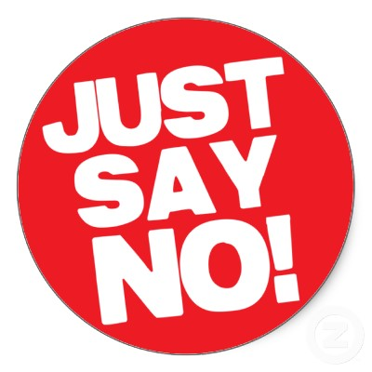
SOCIAL MEDIA AND REFUSAL SKILLS STUDY GUIDE
Name:_________________________________
Period:______

SOCIAL MEDIA

Positive Social Media
- _________________________ and helps to make _______________________.
- Can enable _____________________________________
- Helps people __________________________________ with social groups.

Negative Social Media
- ______________________ in person.
- False sense of ________________________ by how many “friends” or “likes” they have.
- More comfortable ________________________________ that can never be taken back.

Cautions of Social Media
- __________________________________
- __________________________________
- __________________________________
- __________________________________
- __________________________________

Social Media and Your Future
- Your use of social media can impact your ________________________________.
- ___________________________________________ BEFORE putting something online!

Ask Yourself
- How is it going to _____________________________?
- Is it really _____________________________ to post?
- Could it _________________________ career and life?
- Could it ____________________________ future?

REFUSAL SKILLS

Goals of Refusal
- _________________________________
- _________________________________
- _________________________________
Steps for Refusal
- _____________________________________
- _____________________________________
- Identify the __________________________
- Suggest an ___________________________
- _____________________, sell it, and leave the door open
What to Do Under Pressure
- __________________________________________
- __________________________________________
- __________________________________________
- __________________________________________
- __________________________________________

