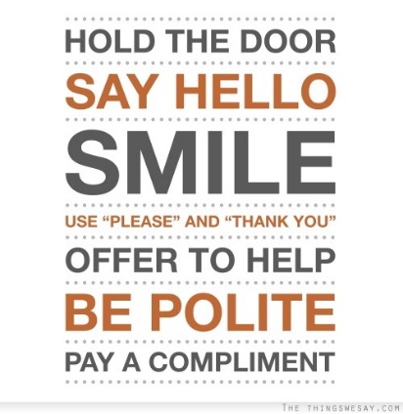
SOCIAL INTERACTIONS STUDY GUIDE
Name: _________________________________
Period: _____

Good Manners and Social Skills
- Using _______________________ and appropriate social skills _________________________ for the people and places around you.
- Allows for communication with _______________________________.
- People will _________________________________, whether good or bad.
Why Social Skills?
- Those who don’t learn appropriate social skills at an early age might:
  - Have ___________________________________________________.
  - Have ___________________________________________________.
  - Have ___________________________________________________.
  - Not be easily ____________________________________________.
  - Have _______________________________ with others.
Basic Social Skills (Simple Manners)
- Be ___________________
- Say “_________________” and “______________________”
- Make _____________________ when talking
- __________________________ for others
- ______________________________________ when appropriate
- Keep _________________________________- and appropriate
- Be __________________________ (on time)
- Use _____________________________________
Important Skills for School Success
- Manage ___________________________ and productively
- Create ____________________________________
- Set _______________________________ often
- Concentrate and __________________________________
- Learn how to be a ______________________________
- Complete assignments/turn them in ________________________
- Get ________________________
- Be motivated to _____________________
- _________________________ (no excuses!)
- Do your best and _________________________________
Important Skills for Employability
- __________________________________ (listening, speaking and writing)
- _________________________
- _______________________________ (solve problems and make decisions)
- Initiative / _______________________________
- Productive and _________________________________
- __________________________ skills
- __________________________
- _______________ management
- Integrity / ___________________________
- ________________________________
- ___________________________ skills (“people” skills)
Other Lost Skills
- Appropriate _________________________
- ___________________________ notes
- Meal time manners / _____________________________
- _____________________
When to Send Thank You Notes
- You _________________________
- You have been a ____________________________________
- Someone does a ________________________________ for you.
- You have gone on a __________________________________.

