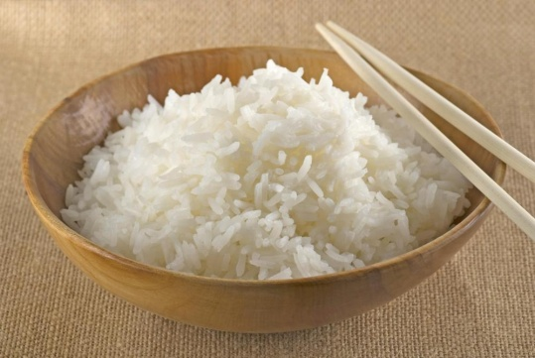
RICE STUDY GUIDE
Name:_______________________________
Period:______
- Types of Rice
  - _______________________________________
    - The _____________ ____________ ___________ of rice.
  - _______________________________________
    - ______________ and then ____________________.
  - _______________________________________
    - Stays __________ and ___________________
  - _______________________________________
    - ______________ ___________________
    - Also known as ________________ ____________

- How to Cook Rice
  - Bring _____________to a ______________.
  - Add rice, ______________ the pan and _____________ __________ to a ___________________.
  - Do _______ ____________ the __________while rice is cooking.
  - Rice is done when all the ___________ has been ________________.
  - ________ cup of ______________ rice makes ___________cups of _____________ rice. This makes a __________ ratio.

