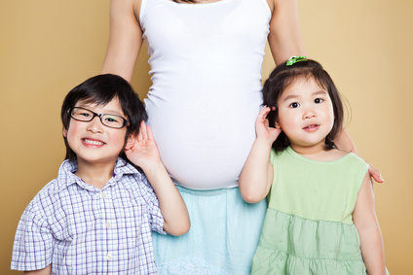
PRENATAL DEVELOPMENT STUDY GUIDE
Name:______________________________
Period:_____

On-Going Prenatal Care
- Often there is a direct correlation between the health of the ______________________and the health of the _____________________.
- If the mom is __________ and ____________________, getting proper _____________, eating _____________, gaining the __________________, the baby will most likely be _______________.
- If the mom has health ____________ or is taking ___________________ into her body, the baby can be __________________________.

Prenatal Terminology
- _______________________________
  - The connection between the ________________________________.
  - It is ________ inches long.
  - Passes _________________________ from the mother to the child
  - Returns _____________________ from the child back to the mother.
- ____________________
  - An organ attached to the _______________________ in the uterus.
  - Filters and transfers _____________ and ____________ to the fetus.
- ______________________________
  - Guards against _____________
  - Keeps the fetus at a ________________________________
  - Keeps the fetus from forming a connection to the _________________________________________
- ______________________________
  - Holds the __________________________
  - Very strong, clear and _______________________________ that surrounds the fetus
  - Before delivery, it is ____________ to allow the baby to exit out of it.
- ________________________
  - The uterus is called a womb when a ___________________________
- ___________________________________
  - Called the ____________________ during ____________of the fetus.

Stages of Prenatal Development
- Prenatal development
  - The development of the baby _____________________________.
  - The prenatal period lasts ______________________
  - There are three stages of prenatal development: _________________________________________________
- Stage 1: _____________________________
  - This stage ____________________________ and lasts until the zygote is implanted in the mother’s uterus.
  - Zygote grows to be about the size of a ____________________.
  - Roots grow from the zygote into the _______________________ where they can receive nutrients from the mother’s blood.
  - Length of time: ______________________________________.
- Stage 2: ____________________
  - Embryo is attached to the mother by the _____________, which reaches from the __________________ to the wall of the ________.
  - Embryo is inside the ____________________________.
  - Length of time: __________________________ of development.
- Stage 3: ________________________
  - __________________________________ that were formed during the embryo period will become much more developed and ____________________________________
  - The fetus will begin to resemble a ____________________________
  - Length of time: _________________________________________.

First Trimester
- The _____________________________ and vulnerability for birth defects depending on ___________________ or does not do during the pregnancy.
- ______________________ of pregnancy are more likely to occur.
- The ______________________________ occurs (every physical feature and vital organs form, heart beats and brain waves begin).
- There is ____________ maternal ________________________.

Second Trimester
- Quickening occurs during the ____________________________
  - Slight ______________________________ felt by the mother
- Increased __________________________________________.
- Physically the ________________________________ on the mother.

Third Trimester
- Physically the _________________________ for the pregnant mom due to _________________________of pregnancy.
- _______________ (fine hair) and ________________(waxy substance) both covering the fetus’s body begin to _________________________.
- Fetus grows and gains weight rapidly: ______________.
- _______________________ the last month to help the baby have a _____________________ once outside of the womb and living as a separate being from the mother.
- _________________ occurs in the ______________________
  - ______________________ movement of the baby into the Mom’s pelvic region in a ____________________ in preparation for delivery

Multiple Births
- Identical Twins
  - ___________________ (egg) is fertilized by _______________ and then __________________________ or more.
  - ___________________ each other
  - Are of the __________________________
- Fraternal Twins
  - Developed from _________________ (eggs), each fertilized by a ___________________________ cell.
  - _______________have to _____________________ each other.
  - _______________have to be the ________________________.
- Conjoined Twins
  - Develop when the _____________________ (identical twins) ____________________ completely _______________________ before developing.

