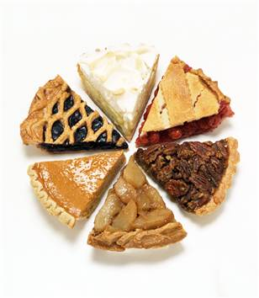
PIES AND TARTS STUDY GUIDE
Name:________________________________
Period:_____

Pies
- A pie is any dish that has a ___________________________________.
- Types of Pies
  - __________________________
  - __________________________
  - __________________________
  - __________________________

Cream/Custard Pies
- The “____________” in cream pies is usually a ___________________.
- Has ___________, milk, _____________________and flavoring.
- The mixture is cooked until __________, then _______________and poured into a _____________, cooled ________________.
- Examples: Lemon, _____________, coconut, butterscotch and __________.
- Need to be _____________________.

Savory Pies
- Contain cooked ________, poultry, ______________ or vegetables in a ________________________________.
- Usually served as a ____________________
- Example: ______________________________
- Need to be ____________________________.

Fruit Pies
- Whole or sliced ________ is combined with ______ and a _____ thickener.
- The ________ of sugar to thickener varies depending on the fruit.
- The ____________and the fruit ___________form into ___________.
- The thickener congeals the syrup to ______________________ as it bakes.
- Common fruit pie thickeners include: _______________________________
- Examples: _______________, strawberry, blueberry
- Can be stored at _____________________________.

Types of Crusts
- Single Pie Crust
  - The crust and filling are ________________________.
    - Pumpkin and pecan pies
  - The crust is _______________________, or blind, and a prepared filling is added later.
    - Custard and cream pies
  - __________________: A bottom crust baked before filling is added.
- Double Pie Crust
  - Divide the dough into __________, one slightly larger than the other.
  - Roll out the ___________________ and fit it into the pan.
  - Make a ___________________ as a solid piece or make a lattice top.
  - Typically ____________________ and ______________ pies

Tarts
- A ___________________ with a _____________________.
- Can be __________________, entrees, or desserts
- Always ________________________________ before serving.
- Examples:
  - ____________________________
  - ____________________________
  - ____________________________

Ingredients in Pies/Tarts
- ________________
  - Helps form the ______________________ of the pie.
  - _________________Flour
    - Used to create a __________________________ textured pie.
    - It is delicate rather than _____________________________.
    - Lower in ______________ and higher in ________________.
- ________________
  - ________________________ and adds flavor.
  - The _____________ of the type of fat used affects the crusts texture.
  - Types of fats:
    - __________________________
    - __________________________
    - __________________________
  - ____________________-based solid fat
    - ____________ melting point that creates a ________________
    - _______________ flavor
- _______________________________
  - ________________________ to the pie crust.
  - Those crusts used for sweet pies may have _____________________ to the dry mixture to _____________________________.
- ______________
  - Helps to form the structure by helping ________________________.
  - ____________________ helps keep the fat from ________________.

Nutrients Found in Pies/Tarts
- Pies can ____________ in healthiness
- Contents can be anything from ___________ to vegetables to __________ or a mix.
- Can have varying amounts of ____________________________
- The pastry casing is __________________________
- Consume foods like cakes, pies and brownies as an ___________________.

