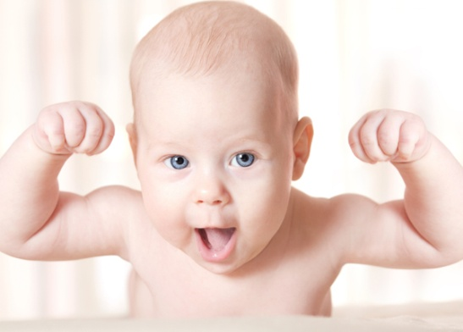
PHYSICAL DEVELOPMENT OF
AN INFANT STUDY GUIDE
Name:__________________________________
Period:______
Age
- Newborns: ____________________________
- Infants: _________________________________
Sequence of Normal Physical Development
- _________________________________
- _________________________________
- _________________________________
- _________________________________
- _________________________________
- _________________________________
- _________________________________
Crawling
- Babies might skip the _________________, but studies have linked crawling to the __________________________ necessary for reading and other cognitive skills.
- Provide ____________that get a child down on the ground to ______________________ during play.
Neck and Eye Development
- Since the neck muscle is __________, place _________________ under their neck to _______________their head and neck.
- A ____________________ above the baby’s head will develop the infant’s ______________________.
Height and Weight
- By the end of their first year, the infant has:
  - Tripled their __________________________
  - Increased their length by ______________________

Nutrition
- If the baby cries, don’t immediately _________________.
- Tears don’t mean _________________ and you don’t want them associating __________________________.
- Never ______________________ a bottle of milk.
Warming a Bottle
- It creates dangerous _______________ in the liquid that will __________________.
- Run the bottle under ______________ until the milk is ________________.
- Set the bottle in a _______________ on the stove and heat to ________________.
- Check the ______________ by shaking a few drops onto your __________.
Bottle Feeding
- ______________ a bottle up in the baby’s mouth causes milk to ________ into their _____________.
- The baby could develop ______________, digestive problems, and _______________________
- The baby will also miss out on the important ________________________.
- Throw away _______________________ that have been sitting in the fridge for over ____________________.
- Bottle fed babies are at risk for _____________ because the caregiver may urge the baby to _____________ left in the bottle, even if the child is ____.
Solid Foods
- At around ____________ of age, the infant is able to digest ____________.
- The infant has control over the ________________ so it won’t spend the majority of feeding time thrusting out its _________________________.
- Introduce ________________ at a time to be able to identify ____________________to food.
Introducing Solid Foods
- First: ___________________________
  - Rice, barley or oats
  - Wait on the _______________ (common allergen for many babies)
- Second: _____________________, yellow/orange varieties
  - Sweet potatoes and carrots
  - Greens (peas and beans) have a slightly stronger flavor
- Third: ___________________
  - Mashed bananas, baby applesauce, peaches, pears
- 7 Months: ____________________
  - Poultry first
  - Beef second
- 7 Months: ______________________
  - Yogurt, cottage cheese, egg yolks
- It is important to ____________________ for feeding infants.
- Some doctors recommend waiting to feed infants baby cereal because so many can develop ___________________ or allergies. Instead, they start babies on _________________________.
Foods to Avoid the First Year
- __________________________________
- __________________________________
- __________________________________
- __________________________________
- __________________________________
- __________________________________
- __________________________________
- __________________________________
- ____________________ (wait until they are 2 years old)
Baby Food Jars
- Never feed a baby _____________from the baby _______________.
- ____________ from the baby’s saliva ________________ in the baby food.
- It begins to ________________ the food and causes it to ______________.
- ____________________ bacteria can grow quickly and lead to __________.
- Pour the food out into a ___________________
Self-Feeding
- Children begin self-feeding at around ____________________.
- Guidelines for self-feeding safely include:
  - ________________pieces
  - Easy to _____________________
  - Nothing that must be ____________________
  - Small ____________________ at a time
  - Watch them ______________________
Follow MyPlate Guidelines
- Give __________________________/portions
- Use their ____________ as a guide for their ________________.
- Help children to enjoy ________________________________.
- _____________ salty, sweet and _______________ foods.
- Provide enough _________________ for rapid growth
- Provide foods rich in ____________________ such as protein, __________, calcium, B-vitamins, ______________________, D-vitamins.
- Foods that are _________________________.
- Adequate amount of ___________________
  - Mostly ___________________
  - Can also provide _______________________

