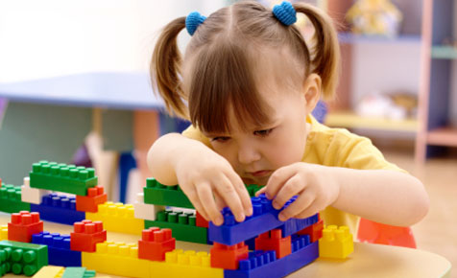
PHYSICAL DEVELOPMENT OF A TODDLER
STUDY GUIDE
Name:_______________________________________
Period:______

Age of a Toddler
- Newborns: __________________________________
- Infants: _____________________________________
- Toddlers: ___________________________________

Walking
- Shows the _____________________ of the toddler stage.
- Generally walk and run with their ______________________ than an adult.
- _______________________ while going downstairs is a challenge for them.
- They are __________________ and want to be ______________________.
- Create a ________________________ for them to explore in.

Development of Motor Skills
- Growth tends to _______________ as the child __________________, but there is __________________ in the _______________________.
- Tricycles and Big Wheels will encourage ____________________________.
- Puzzles and coloring encourage ___________________________________.

Suggested Toys
- Can build with _________________________
- Struggle to use _________________________________________.
- Toys should not have any ______________________________.

Self-Help Skills
- Tasks that the child can do ____________________________.
- ____________________________
  - Simple _____________________ foods
- ____________________________
  - Snaps, zippers and buttons are _______________________________
  - ________________________________, slip-on shirts
- If the child is ____________________ to do it or ____________ attempt it, the caregiver should ________________ and not be so concerned with the _____________________.
- The ___________________ is more important than the ______________________.

Nutrition
- _________________________ is the ____________________ for healthy child development.
- A child’s nutrition affects the health, _________________, and function of their _________________ – brain, __________, eyes, _________________.
- What a child ________ will have a big influence on their ____________, behavior, ______________________, and emotions.

Proper Nutrition
- Follow the guidelines set forth by the ______________________________.
- Because a toddler’s growth is ______________________, they will ____________________ than they did in their _______________________.
- Due to their _____________________ and frequent need for _____________________, it is best to feed them _____small meals, which include snacks, every _____________________.
- Give __________________________/portions.
- Use their ______________________ as a guide for the serving size portion.
- Help children to enjoy ___________________________________________.
- Provide foods rich in necessary _________________ that are _______________________ and __________________________________.
- Limit ______________, sweet and ________________ foods.
- Use ___________________________________ foods cautiously.
- Packaged foods are high in ___________, fat, _____________, preservatives, artificial _____________________ and flavors.
- If it comes in a bright package or with a ________________, it usually is ______________________ choice to eat.
- Adequate amount of ______________________
  - Mostly _____________________
  - ____________________ fruit juice
  - Low-fat ___________________

Toilet Training
- Begins when the child is ____________________________________ ready.
- Treat accidents matter of fact so there is ____________________________ and doubt.
- If the child fights toilet training or is __________________ still after a few weeks, stop and wait about ________________________________ the training again.

