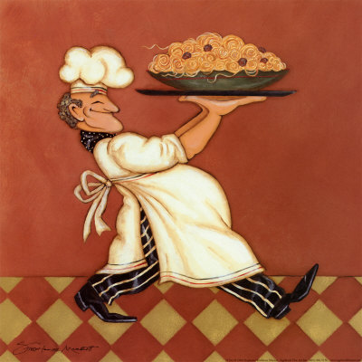
PASTA STUDY GUIDE

Name:_______________________________________
Period:________

- Facts about pasta
  - Pasta dishes are usually ________ ___________ entrees.
  - Store pasta in a ____________ _____________ container at __________ _________________.
  - ________________________________ should be stored in a _______________________ in the ___________________.

- How to cook pasta
  - Bring water to a _____________.
  - _____________ add pasta so as not to ___________ the ______________.
  - Cook _______________ until pasta is _____ ___________ (____________ to the touch)
  - ___________ the pasta _______________ throughout the cooking process.
  - _______ cup of ______________ pasta makes _______ cups of ________________ pasta. That makes a _______ ratio.

