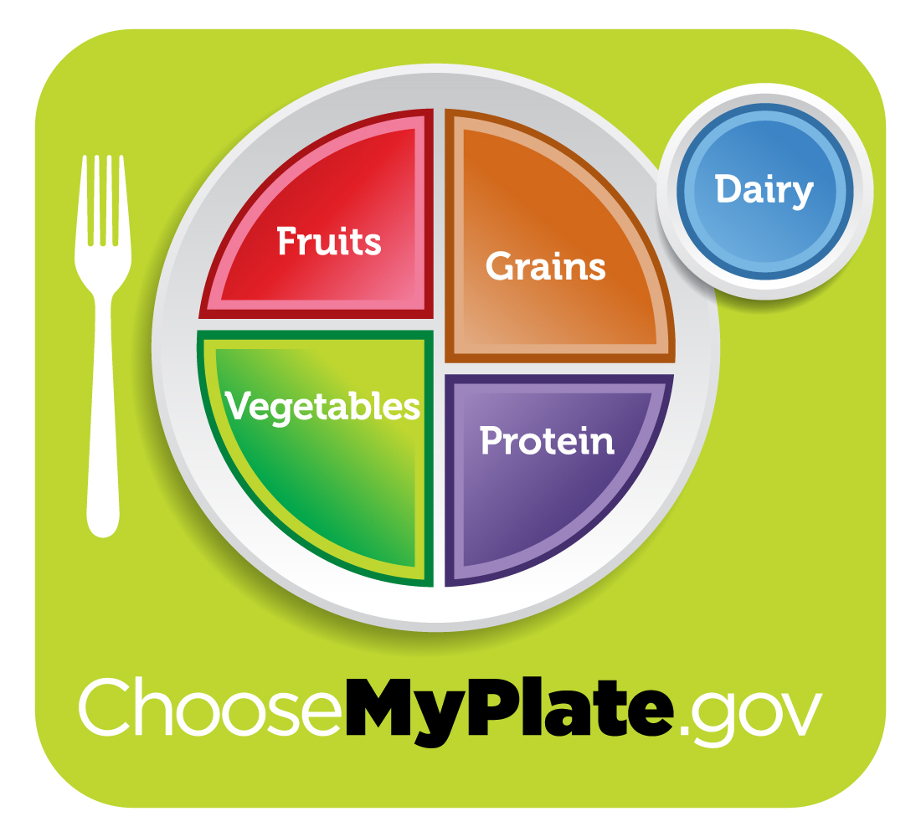
MYPLATE IN A FLASH
INSTRUCTIONS

- Cutting out the flashcards
  - Using the tracing rectangles (2½” x 4¼”),
cut out 5 different colored rectangles.
  - You can use construction paper, colored paper or card stock.
  - The colors should be orange, green, red, blue and purple.

- On the front of each flashcard
  - Label the food group in accordance with the correct color.
  - Glue one picture of a favorite food item for each food group.
  - On the top of each flashcard (the 2 ½” side), fold under ½”.
  - Glue the ½” flap onto the handout. Do not glue the entire flashcard onto the handout!

- Underneath the flashcards on the handout
  - Write the recommendation for each food group.
  - Write the tip for each food group.

- Turning in
  - When you are finished with your project write your name and class period on the handout and then turn into the teacher for a grade.
  - Please turn your project in on time so you can get full points! ☺
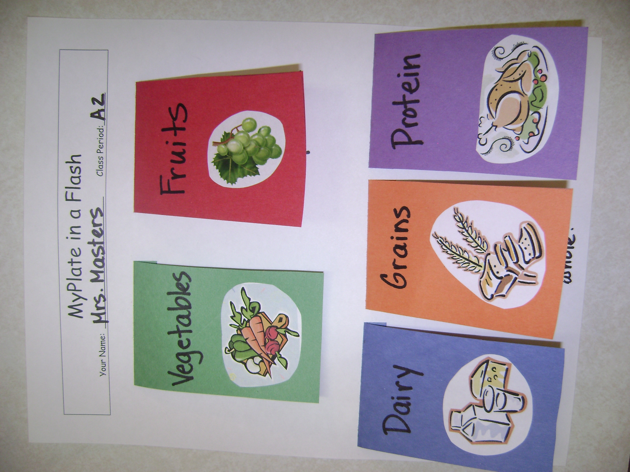
- Grading – 50 points possible
  - Food Group Names – 10 points
  - Examples – 10 points
  - Recommendations – 10 points
  - Tips – 10 points
  - Overall appearance – 10 points

