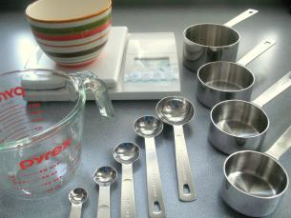
MEASURING TECHNIQUES
Name:_KEY__________________________ Period:_______

- Use dry measuring cups for dry ingredients and level with a straight edge spatula.

- Use liquid measuring cups for liquid ingredients. Measure at eye level on a flat, level surface.

- Brown sugar is packed and leveled in dry measuring cups.

- Shortening is pressed into dry measuring cups and leveled. Shortening can also be measured using the water displacement method.

- Use most effective tools for measuring. For example, use 1/4 cup rather than 4 Tablespoons.

- Use measuring spoons for ingredients less than 1/4 cup. Measuring spoons can measure both liquid and dry ingredients.

- Do not measure directly over the mixing bowl.

