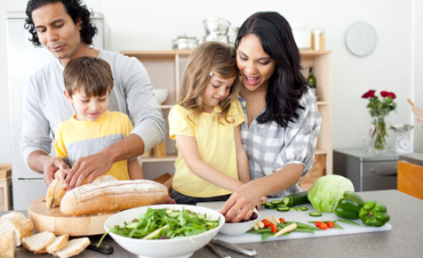
MEAL PLANNING FOR THE FAMILY
STUDY GUIDE
Name:_____________________________
Period:_____

Nutritionally Balanced Meals
- Incorporate the current _____________________________ when planning nutritionally balanced meals.
- Incorporate the ______________________________ when planning nutritionally balanced meals.

Meal Planning Elements
- ___________________________
  - Select food in a ___________________________
    - _______________________________
    - _______________________________
    - _______________________________
  - Add color to ________________________________________
- _____________________
  - Aim for a _______________________________ in a meal
  - Think of ways to ____________________________
- ______________________
  - __________using foods with ____________________ in the same meal.
- ________________________
  - Keep hot foods _______and cold foods _________
  - Use ____________________________ plates
  - Serve foods appropriate for the ____________________________
- _______________________________________
  - Use a variety of _______________________ to add ______________

- __________________________________________
  - Avoid placing food on the _______________
  - Avoid _______________ the plate – allow for ___________________
  - Avoid the use of ____________________ on the plate
  - ______________ are more _________________ than even numbers.

Factors that Influence Cost/Budget
- Influences on Budget
  - ________________________________________________________
  - ________________________________________________________
  - ________________________________________________________
  - ________________________________________________________
  - ________________________________________________________
  - ________________________________________________________
- Set a goal to plan _______________________________________ at a time.
  - It will ______________________ in the long run.
  - Have _______________________________________ in the planning.
- Plan menus based on ______________________ at the local grocery store.
- Fruits and vegetables that are ______________ usually are less _____________and have better __________________.

Create a Work Plan
- What is a Work Plan?
  - List of all the _____________________________ in order to prepare a meal.
  - It should ___________________________________ so that all foods are ready to eat at the ___________________.
- Work Plan Tips
  - ___________________________________
    - Keep ________________________ such as cooking oils/sprays, spatulas, cutting boards, and spices ______________________
  - ___________________________________
    - ________________________________, clear off the counters.
    - This allows more room for ______________________.
  - _________________________________
    - When chopping up veggies for a meal, ___________________.
    - Take the extra, place in a ______________________________ for later use.
  - _____________________________________
    - _______________________________ needed for the meal
    - Vegetables chopped, ________________________, and meats thawed.
    - It will be easier to __________________________ and avoid skipping steps.
  - _______________________________________
    - Fill up the sink with soapy water and _____________________
__________________________________________________
    - It’ll make clean up go much ______________________
  - _______________________________________
    - ________________________ soups, sauces, or gravies in small reusable containers.

