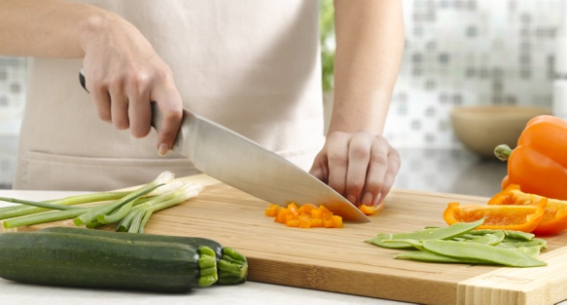
KNIFE SKILLS STUDY GUIDE
Name: ________________________________
Period:______

Cutting Boards
- A cutting board is used to ___________ to prevent damage to the _______________ and to prevent _____________________.

Wooden Cutting Boards
- Keep ___________________ longer
- Are porous and ____________________________ more easily

Plastic Cutting Boards
- Can _____________________________
- ________________________ because it’s easier to sanitize
- Available in __________________________
- _______________ is designed for use with a ________________________.
- Adopting a _________________________ reduces cross contamination.

Stabilizing Cutting Boards
- Place a ______________________________ the cutting board.

Sanitizing Wooden Cutting Boards
- Scrubbing in ______________________________
- Use a _____________________________ solution
- ______________ put in the __________________________
- ____________________________ in water

Sanitizing Plastic Cutting Boards
- Scrubbing in _____________________________
- Use a ______________________ solution
- Wash in the ________________________

Use of Cutting Boards
- It is advised to _____________ on a separate cutting board from ________, _______vegetables or ready to eat foods to prevent __________________.

Chef’s Knife
- Among the most ________________________
- Used for daily ______________, slicing, _______________ and mincing.

Paring Knife
- This indispensable knife is handy for ______________________________
- ____________, peeling, __________ and slicing small fruits and vegetables.

Serrated Knife
- A serrated bread knife ________, fresh loaves without ________________.
- It’s also great for cutting _______________________.

Care of Knives
- Should not be washed in the ____________________ or placed in the __________________________.
- ____________________ immediately after the knife enters the dishwater with __________________________.
- ______________________________

Storage of Knives
- _______________________
- Cover each blade with a _______________________
- Knives should not be stored ______________ with other knives or utensils.
- The knives will ____________________ and the blade will _____________.
Batonnet Knife Cut
- French word for _____________________.
- Size: ________________________________________

Julienne Knife Cut
- Size: _________________________________________

Brunoise Knife Cut
- Begin with ______________________________________________.
- Size: ___________________________________________________

Small Dice Cut
- Size: ____________________________________________________

Medium Dice Cut
- Size: ____________________________________________________

Large Dice Cut
- Size: ____________________________________________________

Diagonal Knife Cut
- Cut on a __________________________________________

Chiffonade Knife Cut
- Cutting ______________________ into long, thin strips.
- _____________leaves, _____________________ then slicing the leaves ________________________ to the roll
- Size: ________________________________________

