KITCHEN MATH,
EQUIVALENTS AND
ABBREVIATIONS

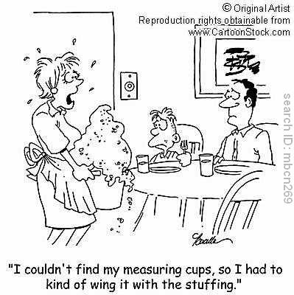

Name: Teacher Key

- Know the proper order of measurements
Cups:
(smallest) 1/4, 1/3, 1/2, 2/3, 3/4, 1 (largest)

Measuring Spoons: (smallest to largest)
1/8 tsp., 1/4 tsp., 1/2 tsp., 3/4 tsp., 1 tsp., 1/2 Tbsp., 1 Tbsp.

- Know the following abbreviations

Gallon: gal.

Pint: pt.

Pound: lb. or #

Hour: hr.

Teaspoon:tsp. or t.

Quart: qt.

Cup: c.

Ounce: oz.

Minute: min.

Tablespoon: T. or Tbs. or Tbsp.

- Gallon Equivalents
1 Gallon

1 Quart
1 Quart
1 Quart
1 Quart

1 pt
1 pt
1 pt
1 pt
1 pt
1 pt
1 pt
1 pt

Each small box = 1 cup
- Cup Equivalents
1 Cup

1/2 Cup
1/2 Cup

1/4 c.
1/4 c.
1/4 c.
1/4 c.

Each small box = 1 Tablespoon

- Know the following equivalents:

3 tsp. = 1 Tbsp.

4 qt. = 1 gal.

2 c. = 1 pt.

4 Tbsp. = 1/4 c.

16 c. = 1 gal.

1 stick butter = 1/2 c.

16 Tbsp. = 1 c.

8 fl. oz. = 1 c.

16 oz. = 1 lb.

RECIPE RACE

For the recipe below, change the measurements so that the recipe is doubled and then change the measurements so the recipe is halved. The team done first and with the correct changes wins!

DOUBLED INGREDIENTS HALVED

1 1/3 c. 2/3 cup shortening 1/3 c.

1 1/3 c. 2/3 cup butter 1/3 c.

2 c. 1 cup sugar 1/2 c.

2 c. 1 cup brown sugar 1/2 c.

4 eggs 2 eggs 1 egg

6 c. 3 cups flour 1 1/2 c.

1/2 tsp. 1/4 tsp. baking soda 1/8 tsp.

1/2 tsp. 1/4 tsp. salt 1/8 tsp.

24 oz. 12 oz. chocolate chips 6 oz.

1 c. 1/2 cup nuts 1/4 c.

KITCHEN EQUIVALENTS BINGO
Directions: Place the answers below into each of the boxes on your bingo card. Place each answer into a different box from your classmates so as not to have the same bingo card. No Free Spaces!!
Answers:

8 c.
1 c.
3/4 c.
1/2 c.
1/4 c.
1 gal.
1/2 gal.
16 oz.
1 pt.
2 pt.
4 pt.
1 Tbsp.
8 Tbsp.
16 Tbsp.
1 qt.
4 qt.

