**KITCHEN EQUIPMENT**

**Be able to identify and describe the use of the following kitchen equipment.**

1. Bread Knife

Used for: Cutting bread without flattening it.

* 1. 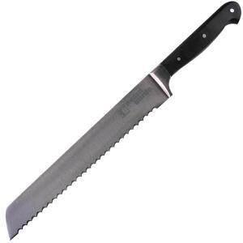

1. Cutting Board

Used for: Cutting meats or vegetables on.

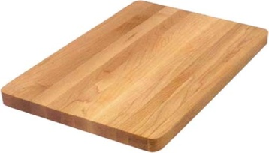

1. Oven Thermometer

Used for: Measuring the temperature inside an oven.

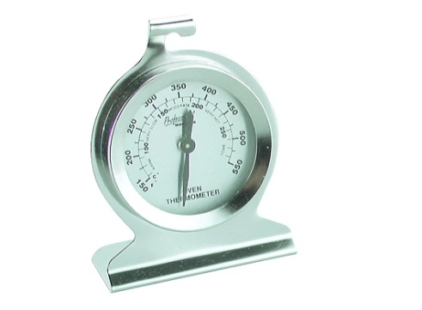

1. Pastry Blender

Used for: Cutting fat into flour.

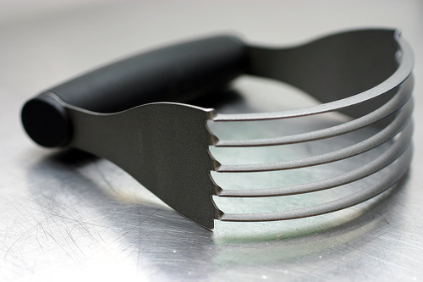

1. Slotted Spoon

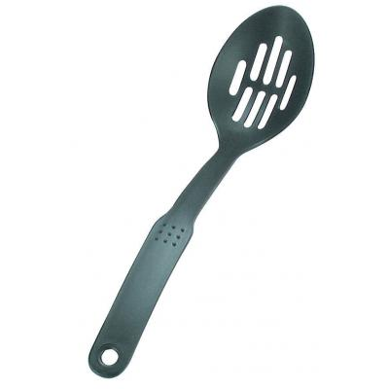

Used for: Draining liquid from food.

1. Vegetable Peeler

Used for: Peeling fruits and vegetables.

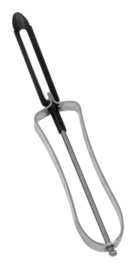

1. Chef’s Knife

Used for: Main knife used in food preparation.

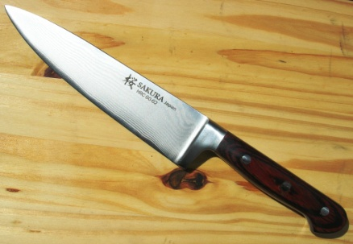

1. Ladle

Used for: Serving soups, stews or sauces.

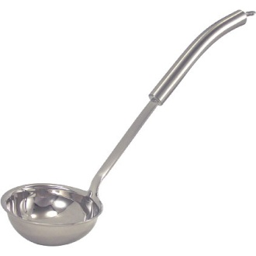

1. Pancake Turner

Used for: Turning and serving.

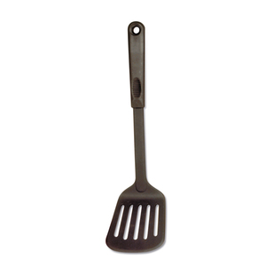

1. Rolling Pin

Used for: To flatten or shape dough.

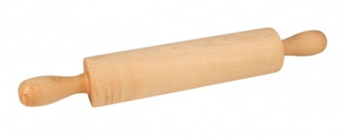

1. Straight Edge Spatula

Used for: Leveling off ingredients or spreading frosting.

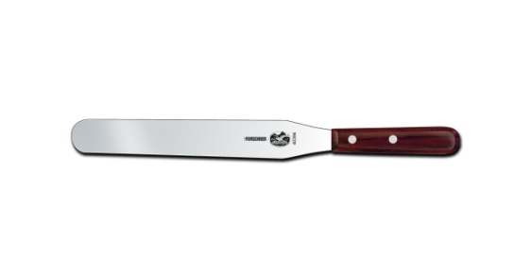

1. Wire Whisk

Used for: Blending liquids.

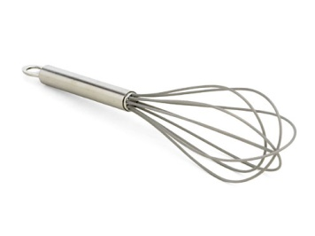

1. Colander

Used for: To separate liquid from larger food items such as vegetables and pasta.

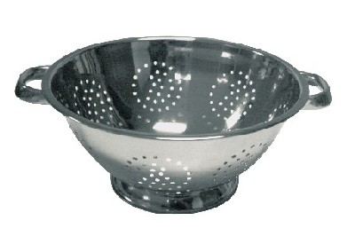

1. Strainer

Used for: To separate liquid from smaller food items such as berries.

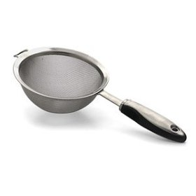

1. Meat Thermometer

Used for: Measuring the inside temperature of meat.

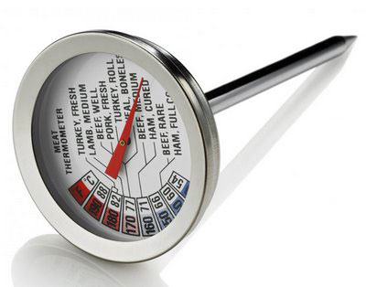

1. Paring Knife

Used for: Paring (removing the skin from) fruits and vegetables. Also used in garnishing foods.

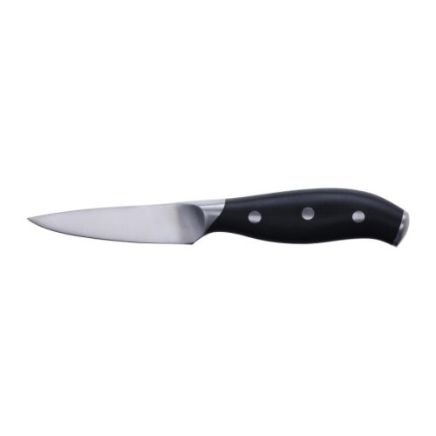

1. Rubber Scraper

Used for: Folding, mixing and scraping dough and batters out of bowls.

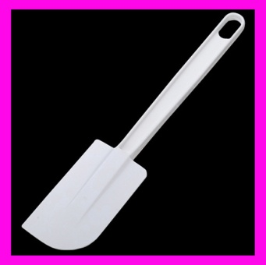

1. Tongs

Used for: Picking up and holding things.

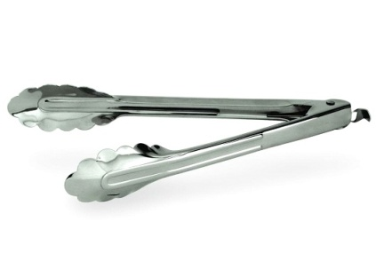

1. Wooden Spoon

Used for: Cooking on top of the stove.

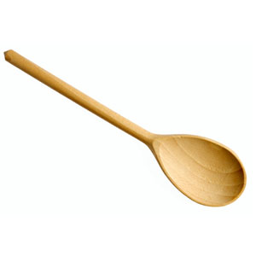

1. Measuring Spoons

Used for: Smaller measurements used for both liquid and dry ingredients.

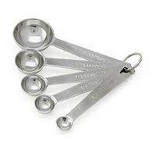

1. Liquid Measuring Cup

Used for: Measuring liquids such as milk, water or oil.

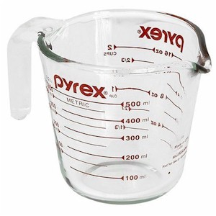

Used for: Measuring dry ingredients such as flour, sugar or rice.

1. 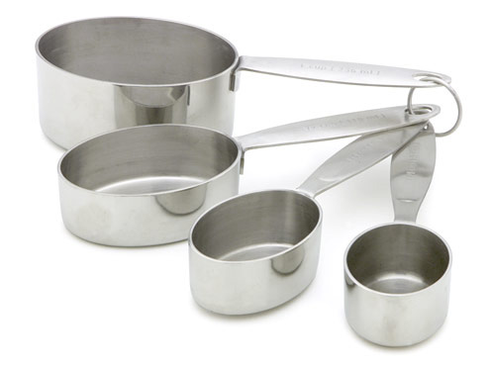 Dry Measuring Cup