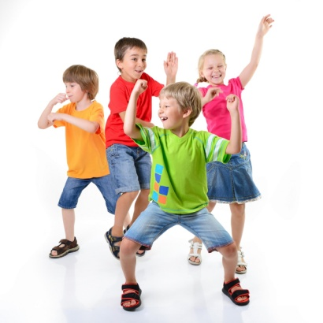
GROWTH AND DEVELOPMENT STUDY GUIDE
Name:___________________________________
Period:_____

Development of a Child
- Child Development:_____________________________________________
_____________________________________________________________
- The five stages of development are:
  - ________________________________________________________
  - ________________________________________________________
  - ________________________________________________________
  - ________________________________________________________
  - ________________________________________________________

Definitions
- Growth:____________________________________________________________________________________________________________________
- Development:_______________________________________________________________________________________________________________

Laws of Growth and Development
- Growth proceeds from __________________________________________
  - The infant needs to hold their head up before they can crawl.
- Growth proceeds from __________________________________________
  - The infant needs to move their arm before they can move fingers.
- Growth proceeds from __________________________________________
  - The infant holds their head up, rolls over, crawls, walks.
- _____________________________________________________________
- _____________________________________________________________
- _____________________________________________________________
- _____________________________________________________________
- _____________________________________________________________

Physical Development
- Children develop most rapidly during _______________________________
- _____________________ are the coordinated movements of body parts.
- Two types of motor skills:
  - ________________________________________________________
  - ________________________________________________________
- Most children follow a natural physical development sequence:
  - ________________________________________________________
  - ________________________________________________________
  - ________________________________________________________
  - ________________________________________________________
  - ________________________________________________________
  - ________________________________________________________

Social Development
- Socialization is the process of:
  - ________________________________________________________
  - ________________________________________________________
  - ________________________________________________________

Emotional Development
- Learning to ____________________________________________________
- Learning to ____________________________________________________
- _____________________________________________________________
- _______________________ was the main theorist.

Cognitive Development
- Intellectual Skills
  - ________________________________________________________
  - ________________________________________________________
  - ________________________________________________________
- Positive feedback for accomplishments encourages children to continue ____________________________________________________________.

- Children learn:
  - ________________________________________________________
  - ________________________________________________________
- A sensory stimulating environment:
  - ________________________________________________________
  - ________________________________________________________
- ______________________ development is a cognitive task.
- ______________ correctly (_______________) to the child will help them learn correct _____________________________________.
- ______________________ was the main theorist.

Moral Development
- _____________________________________________________________
- __________________________________ (modeling) is the best way to teach moral development to children.

Interrelationships
- All of these areas of development have their unique traits, but they are all _____________________________________________________________.
- _____________________________________________________________
Draw the interrelationships chart below:

