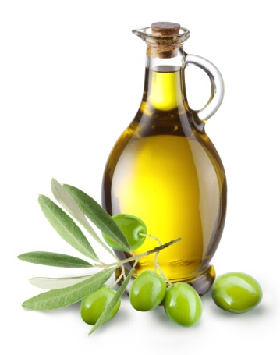
FATS STUDY GUIDE
Name:________________________________
Period:__________

- Functions of Fat
  - Carrier for Vitamins _____, _____, _____ and _____
  - ___________ supply of _____________
  - Adds __________ in food
  - Satisfies ______________
  - Protects internal _________ from shock and ____________
  - _____________ the body from shock and _______________ changes
  - Promotes _____________ ___________
  - Helps you ________ ______ ___________

- Facts About Fats
  - Fats provide ____ calories per gram.
  - It is the most _____________ source of ___________.
  - ________ are not a food group, but they do provide _____________ ___________________.

- Cholesterol
  - Cholesterol is _____________for many body _____________.
    - Produces ______________ and ________ acids.
  - Cholesterol is a ______________ substance ________ by the ______, thus ______________ the need to include it in your ______.
  - Cholesterol is found in _____________tissues, but is _____________ present in _______________.
  - Two types of cholesterol – __________ and ___________

- HDL Cholesterol
  - Stands for ___________ ____________ Lipoprotein
  - Function: Transports ________ cholesterol found in the blood stream back to the __________.
  - Considered “___________” cholesterol

- LDL Cholesterol
  - Stands for _______ __________ Lipoprotein
  - Function: Takes cholesterol from the __________ to wherever it is _____________ in the body.
  - Considered “_______” cholesterol

- Why is LDL Cholesterol Bad?
  - If too much LDL cholesterol is circulating in the blood stream:
    - It can _________ _____ in the arteries
    - ___________ the chance of _________ disease or _________.
    - Factor related to ____________.

- Four Types of Fats
  - ______________________ Fats
  - ______________________ Fats
  - ______________________ Fats
  - ________-Fatty Acids

- Saturated Fats
  - Function: Raise the _____ and _____ levels of cholesterol in the blood.
  - Food Sources: Meat, ______________, whole milk, tropical oils, ____________, _____________ and lard.
  - Most __________ fats are ___________ in saturated fats and are solid at ______________ temperature.

- Polyunsaturated Fats
  - Function: Lower both the _____ and _____ levels of cholesterol in the blood.
  - Food Sources:
    - ______________ oil
    - ______________oil
    - ______________oil

- Monounsaturated Fats
  - Function: Lower the _____ and raise the _____ levels of cholesterol in the blood.
  - Food Sources:
    - _______________ oil
    - _______________
    - _______________
    - _______________
    - _______________ oil

- Trans-Fatty Acids
  - Function: Raise the _____ and lower the _____ levels of cholesterol in the blood.
  - Food Sources:
    - _________________
    - _________________ foods
    - _________________ foods

- How to Lower Fat in Diets
  - Choose __________ meats.
  - Do not eat poultry ____________.
  - Choose _____________ fat or _____-fat _____________ products.
  - Replace ____________ fats with _______.

