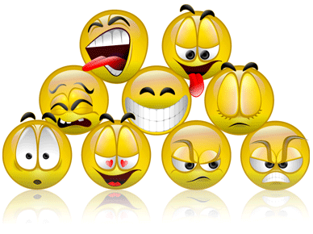
EMOTIONS STUDY GUIDE
Name: _____________________________
Period:_____
What are Emotions?
- Indicators of how a person is ___________________________.
- Body expresses emotions in many ways:
  - ______________________ or a racing heart
  - _______________________ or a red face
  - _____________________ in the stomach
- Because of hormonal changes, teenagers experience a _________________ of emotions in _______________.
- There are _________ basic emotions.
  - ________________________
  - ________________________
  - ________________________
  - ________________________
  - ________________________
  - ________________________
The Hardest Emotion
- _____________ is one of the _____________ emotions to _____________________________________positively.
- What can uncontrolled anger lead to?
  - __________________________________
  - __________________________________
  - __________________________________
  - __________________________________
  - __________________________________
Physical Effects of Uncontrolled Anger
- ___________________________________
- ___________________________________
- ___________________________________
- ___________________________________
- ___________________________________
- ___________________________________
- ___________________________________
- ___________________________________
Well-Managed Anger
- What can well-managed anger be useful for?
  - Motivate you to ______________________________________
Healthy Way to Express Anger
- _____________________ from the situation until _____________________ of your emotions.
- __________________________________ the emotion.
- Try to ________________________________________ why you feel angry.
- ________________________________________ for dealing with the situation in advance.
- Do something physical like _________________ or playing a sport.
- _________________________ if needed.
Passive Behavior
- People who _____________________________________.
- They ____________________ and allow others to make decisions for them.
- They lack the courage to ________________________________.
- They are _____________________
- They are ______________________ by others.
- They see something wrong, but __________________________________.
Aggressive Behavior
- Always _____________________________________________
- They are right in the _____________________________________________
- Masters at ___________________________________________
- Thrive on __________________________________________
- Believe that ___________________________________________________
- They bring out the ______________________________________.
Assertive Behavior
- Calmly state feelings in a _________________________________
- Does __________________________ to manipulate, intimidate or control their behavior
- They use ______________________________
- Can walk away and ______________________ if appropriate
- Can ________________________ if the situation is harmful, dangerous or ___________________________.
Consequences of Emotions
- _______________________
  - The results in choosing behavior that are ______________________.
- _______________________
  - Those factors that _________________________________________ because of the behavior.
- _______________________
  - ___________________________, family, and individuals because of behavior.
- _______________________
  - ___________________________________ that are violated because of the behavior
- _______________________
  - _____________________________ that can come to people because of the behavior.
- _______________________
  - ______________________ to individuals and communities as a result of behavior.

