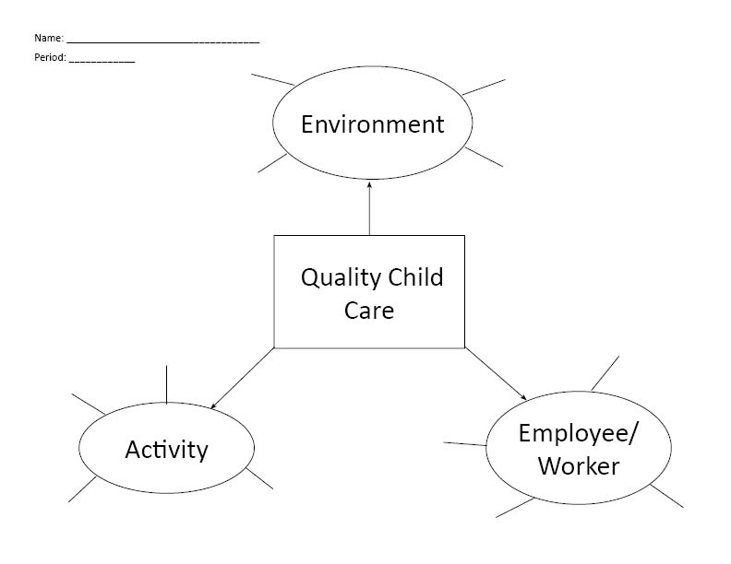

**CONCEPT MAP ASSIGNMENT**

**Name:______________________________ Period:_______ Score:_____/20**