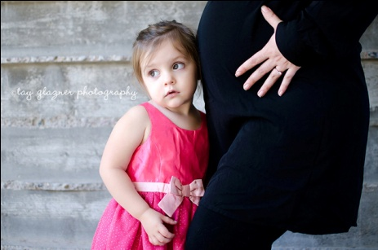
CHARACTERISTICS OF PREGNANCY
Name:________________________________
Period:_____

Gestation Period
- Women are pregnant for how long?
  - _____ weeks
  - _____ months
  - _____ days
- This period is called the ___________________ period.

Female Reproductive System
- __________________________________
- The female _____________________________.

- ___________________________________
- Two almond shaped organs that __________________________ cell.

- ___________________________________
  - A passageway to _______________________ from the ______________________________________.
  - During fertilization, they transport _________________ from the uterus to the released ______________.

- ___________________________________
  - The place where the ____________________ if it has been fertilized.
  - Provides ______________________________________ to the fetus.
  - The ____________________ during pregnancy to hold the growing fetus and ___________________ during labor to deliver the child.

- ____________________________________
  - Functions as the _______________________________________.
  - ____________________________________ for the fertilized egg.
  - If it is not used, it is sloughed off as ___________________________.

- ________________________________________
  - The _________________________________ that leads to the vagina.
  - Helps to _________________________ in the uterus.
  - In order for birth to occur, the _______________________________.

- ________________________________________
  - The _____________________ leading from the external genitals to the cervix of the uterus.
  - Passageway for ___________________________________________
___________________________________.
  - During birth, it is referred to as the _________________________.

- _________________________________________
  - The area between the _____________________________________.

Ovulation and Conception
- _____________________ are released from the ovaries during ovulation to begin the _________________________.
- ____________________ of the ovum by the sperm takes place in the _________________________.
- Only _______________ may penetrate and _________________________.
- The fertilized ovum ______________ into the ________________________ within the uterus.

Signs and Symptoms of Pregnancy
- _______________________________________
- _______________________________________
- _______________________________________
- _______________________________________
- _______________________________________
- _______________________________________

Discomforts During Pregnancy
- _________________________________________
- _________________________________________
- _________________________________________
- _________________________________________

Teen Pregnancy
- Teens have a higher risk of _______________________ baby which can cause many ____________________to the developing fetus.
- Teens often ___________________________________ to the fetus because they are ______________________ themselves.
- Their diet, especially if it is a _____________________________, may also be a factor in the _________________________________.
- The fetus receives the ________________that are ____________________ after the body of the teen mom receives the nutrients that it needs.

