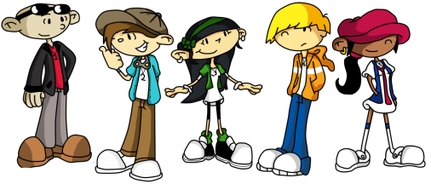
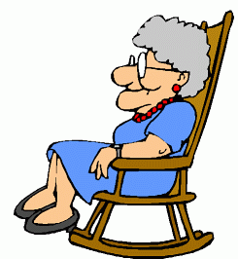
TEENS AND ELDERLY STUDY GUIDE
Name:______________________________
Period:______

- At what age are you considered to be old?
  - Infancy:___________________________________
  - Preschool:_________________________________
  - Childhood:________________________________
  - Adolescence:______________________________
  - Early Maturity:_____________________________
  - Maturity:_________________________________
  - Late Maturity:_____________________________
  - Old Age:__________________________________

- Define Grandparent:_____________________________________________

- What do you have in common with your grandparents?
  - ________________________________________________________
  - ________________________________________________________
  - ________________________________________________________
  - ________________________________________________________
  - ________________________________________________________
  - ________________________________________________________
  - ________________________________________________________
  - ________________________________________________________
  - ________________________________________________________
  - ________________________________________________________
  - ________________________________________________________
  - ________________________________________________________

