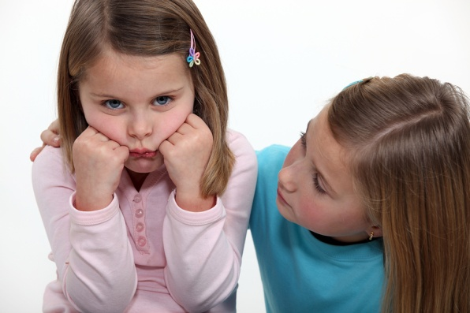
Emotional and Social Development
of a Preschooler Study Guide
Name:_______________________________
Period:_____

Emotional Characteristics
- Gaining _______ inner self-_______ and self-______________of emotions.
- Can begin to _________to other’s ______________.
- ________________________________________
  - Sometimes they want to be and insist on being independent. They __________________ from adults and others.
  - Other times they are very dependent and ______________________.
  - As a caregiver, show unconditional ___________________________.
  - Know when to help and when to ____________.
- ____________________________
  - Fear and anxiety is a ___________________________ against danger. Too much or too little fear and anxiety is not healthy.
  - Fear and anxiety become __________________ during the preschool years. (Monsters under the bed, vampires, etc.)
  - Caregivers should listen to and ____________the fears, assure that you will __________________, be a role model of _______________.
- _____________________________
  - _________________is a feeling, an emotion.
  - _________________ is an attempt to hurt someone or something.
  - Preschoolers need to learn how to get rid of and deal with their feelings of anger in an ____________________________.
  - Preschooler’s aggressiveness should never be disciplined with aggressive forms of _________________________.
  - __________________aggressive acts from occurring. Redirect behavior, eliminate competition, encourage cooperation.
- _______________________________
  - Jealousy occurs when a child recognizes that they must ___________ __________________ and attention of an adult with another person.
  - When that other ________________, then it becomes sibling rivalry.
  - Caregivers should discuss the child’s ________________.
  - Caregiver and child should spend their own _____________ together.
- __________________________
  - Preschoolers are just beginning to __________________________ the concept of death and grief.
  - Caregivers should answer the child’s questions _________________.
  - Caregivers should explain, truthfully, their ______________________ concerning death on the child’s level.
  - Adults should allow the child to see them _______________ at times.

Social Characteristics
- More able and ____________________________ with others.
- Having _____________________ is common, normal, and shows good social and emotional skills.
- If a child does ___________ with real friends, then this could be a _______.
- They are _________________ and realize that having friends outside of their family is fun.
- Can learn specific __________________ in the preschool environment:
  - Taking ______________
  - ____________ still for longer periods of time
  - Raising ______________
  - Improving ___________________

Movement
- ___________________ is the child’s first way of ____________________.
- Personal movement shows the ______________________ of an individual.
- ______________________ shows their _______________ in their own way.
- Movement also builds a child’s ______________________.

Initiative vs. Guilt
- ___________________stage of development
- Initiative:
  - The decision and motivation to ___________________ than expected or asked.
  - The desire to accomplish tasks is based on the child’s ______________________________________________
- Play is a child’s _________. Children are ________________ during this stage.
- Children who are _______________, allowed, and supported in these efforts develop _________________ (the belief in one’s abilities).
- _____________________ or punishment may lead to feelings of ________, inferiority, or inadequacy.

Teaching Moral Behavior
- Toddlers _______________ their parents and other caregivers set, but they _____________________________________ behind the rules.
- Toddlers do understand that some actions make a caregiver ______________ and others make a caregiver _________________.
- They choose the latter behavior so they do not __________________ of their caregiver.
- Preschoolers are ______________________ the reasons behind the rules and develop a _________________(inner sense of right and wrong).
- Their conscience will guide their behavior and help them to make ________________________________
- The caregiver has a _________________________ and help a child develop moral behavior.
- They can be a good role model of it by:
  - Setting clear ______________________________
  - Respond to _____________________ and talk about them in private
  - Continue to ______________ despite the misbehavior

