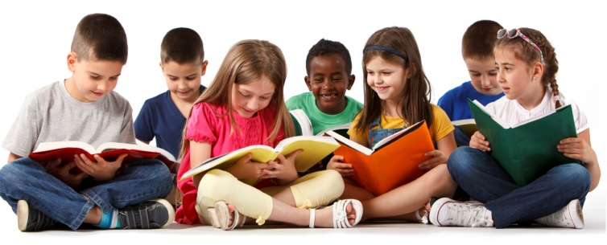
Cognitive Development of a
Preschooler Study Guide
Name: _____________________________
Period:_____
Piaget’s Preoperational Stage
- Preschool children are in Piaget’s _________________________________ of cognitive development.
- Toddlers and preschoolers form ___________________________________ that can last a lifetime.
- Children learn from ___________(hands-on and tangible) ______________.

Egocentric
- Still think in terms of their own _____________and their _______________ at the moment.
- Struggle with ______________________.
- Continue to learn through ____________________________
- Learning that objects and words can be ______________________ an idea.
- ___________________ on ideas because these are based on the child’s perceptions.

How Preschoolers Learn
- Children are _______________and ask many questions because they are ______________and want to understand the world around them.
- Preschoolers learn by _________________________________ in everyday experiences.

Four and Five Year Olds
- Four Year Olds
  - Learn _____________________________
  - _____________________________ the differences between objects
  - Have an expanded ___________________________
- Five Year Olds
  - Begin __________________________
Reality and Fantasy
- Preschoolers can differentiate between __________________________ or make-believe.
- The imaginary life of kids is ______________and sways their __________of the real world until they master ___________________________ and logic.
- Jean Piaget said that kids in the preoperational stage of cognitive growth use ____________________ until they learn the properties of __________________________________

Cognitive Development Terms
- ______________________________
  - Even though one property of an object ________________, the other properties ______________________.
  - Examples:
    - A ball of play-dough smashed into a pancake is still the same even though it looks different
    - Liquid is the same amount even though it is poured into differently shaped glasses.
- ______________________________
  - Putting objects into ________based on ___________________.
  - Examples:
    - Cats and dogs
    - Toy blocks and toy trucks
- ______________________________
  - Placing classified objects into smaller ___________based on how they are ___________________________.
  - Examples:
    - Sorting cats by color
    - Sorting blocks by size or shape
- ______________________________
  - Putting objects in a __________________ based on size, weight, etc.
  - Example: Lining crayons up in order from shortest to longest.

- ___________________________________
  - The change of an object from _________________________.
  - Examples:
    - Popcorn kernel to popcorn
    - Bread dough to bread
    - Jell-O powder to Jell-O
- ___________________________________
  - What can be _________________ can also be _________________.
  - Examples:
    - A sand castle can be built and knocked down
    - A jacket can be zipped up and unzipped
    - A mistake can be made and fixed

