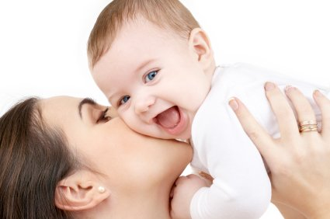
SOCIAL AND EMOTIONAL DEVELOPMENT
OF AN INFANT STUDY GUIDE
Name: _______________________________
Period:_____
Emotional Development
- The process of learning to ____________________________ and learning to establish one’s _________________________________.
- Emotional development begins ___________________________________.

Positive Emotions
- ________________________________
- ________________________________
- ________________________________

Negative Emotions
- ________________________________
- ________________________________
- ________________________________
- ________________________________

Social Development
- Process of ____________________ and to __________________ to others.
- Infants are ______________________________________.
- They like to be _________________________________________________.
- Newborns prefer to look at and interact with the _____________________.

Social Development Stages
- Newborns – Responds to ___________________________
- 1 month – Stops crying when lifted. _______________________ when sees a familiar face.
- 2 months – ________________
- 3 months – Wants _____________________________
- 4 months – Laughs and looks for others to __________________________.
- 5 months – _______________________________
- 6 months – _______________________________
- 7 months – _______________________ over anyone else
- 8 months – Looks for _______________________
- 9/10 months – ________________________; underfoot
- 11/12 months – Center of ________________________

Trust vs. Mistrust
- During the first year of life, the infant is _____________________________ around themselves and the people in it.
- This is Erickson’s developmental stage – ____________________________
- Infants need _______________________________________ to build trust.

Mistrust Cycle (Draw and label the circle below)

Trust Cycle (Draw and label the circle below)

How to Build Trust
- ____________________ with the baby
- Showing __________________________________
- _________________________ the child
- Meeting the __________________________ in all areas of development

Benefits of Building Trust
- Know that the _________and the ___________are comfortable and _____.
- These things are good and can be __________________________.

Anxiety
- Usually appears around _____________________.
- _______________ anxiety
  - _____________________________ and the child cries or appears to be ________________________.
- _______________________ anxiety
  - Separation from a _________________________________________.

Role of Play
- Play ___________________________________ of development.
- Children ____________________________________.

Types of Play
- ______________________Play
  - _________________________ or engaged in activities that only need one person.
- ______________________ Play
  - Sitting back and __________________________ as if observing them or waiting for __________________________ in the activity. (example – Duck, Duck, Goose)

