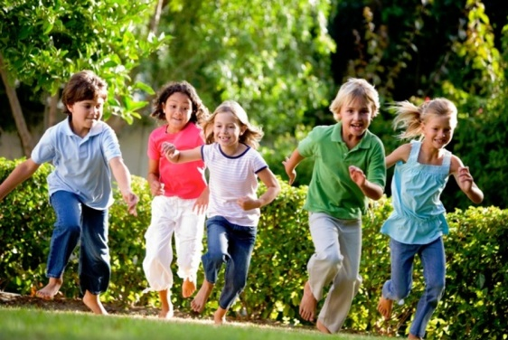
PHYSICAL DEVELOPMENT OF A PRESCHOOLER
Name:___________________________________
Class Period:_____

- Physical Characteristics
  - Physical growth ___________________________ greatly.
  - Size varies due to individual _________________________________.
  - Bodies have become ______________________________________.
  - Protruding stomach from babyhood _________________.
  - ___________becomes _________________.
  - Legs ___________________ and grow ________________and firmer.

- Physical Skills
  - Very ______________________________.
  - Skills are practiced by participating in the action ________________.
  - There begins to be a _____________________________ of gross and fine motor skills.

- Gross Motor Skills
  - Define: ____________________________ your body makes with their arms, legs, feet, or entire body.
  - Examples: Running, ___________________ and throwing

- 4 Year Old Gross Motor Skills
  - Stand on ______________________
  - Throwing and ________________________
  - Hopping on ______________________
  - ____________________________ walking up and down the stairs
  - Walking _________________________

- 5 Year Old Gross Motor Skills
  - Improved _____________________________________
  - Turning ________________________________
  - _____________________________
  - _________________________on one foot

- Fine Motor Skills
  - Define: ____________________________ your body makes with fingers, toes, wrists, lips, and tongue.
  - More refined _________________________ (ability to use your hands and fingers)
  - Better ______________________________________
  - Examples: Cutting, ______________________, painting

- 4 Year Old Fine Motor Skills
  - Put on and ___________________ their own coats
  - Cut with _____________________
  - Complete ________________________
  - _______________________ of the alphabet

- 5 Year Old Fine Motor Skills
  - ________ their own _____________
  - _____________________ with a head, body, arms and legs
  - Stay _______________________________
  - Using a __________________________ to eat
  - Definite _________________________ for being right or left-handed

- Role of Play
  - Play is a _________________________.
  - It is how they __________________________ around them and all the areas of development.
  - Continues with solitary, ___________________ and parallel play.
  - But now because of their ______________, help, and do things another person’s way, it allows them to engage in _______________.

- Cooperative Play
  - Define: Children play and ______________________________
  - Examples:
    - Building a _____________________ together
    - Playing ________________________
    - Acting out a ____________________

