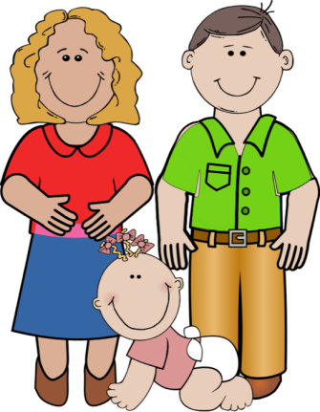
PARENTING RESPONSIBILITIES STUDY GUIDE
Name:_______________________________
Period:_____

Children in Society
- What is the importance of having children in today’s society?
  - ________________________________________________________
  - ________________________________________________________
  - ________________________________________________________

Childhood Shapes Adulthood
- How a child is ___________, guided, provided for, __________, talked to, and ______________ teaches them how to act.
- A child can choose to _____________ these ways and act this way or they can ____________ the cycle and take a ___________________ path.
- What we ____ to a child can _____________ them and the society forever.

A Child’s Bill of Rights
- _____________________________________________________________
- Proper _____________, healthful and safe living ______________, and appropriate ________________ and __________________________ care.
- _____________________________________________________________
- _____________________________________________________________
- _____________________________________________________________
- _____________________________________________________________
- Protected from ______________, parents included, who may _____________ or mentally _____________ them.
- _____________________________________________________________

Parenting Responsibilities
- Parents are ____________ responsible to provide for a child’s __________.
- In a parent-child relationship, the ___________ does the _____________ and the ______________ does the ____________________.
- Parents should ____________ all they can about how children _________ and _________________.

Becoming a Parent
- What should a person consider before determining their readiness for parenthood?
  - ________________________________________________________
  - ________________________________________________________
  - ________________________________________________________
  - ________________________________________________________
  - ________________________________________________________
  - ________________________________________________________
  - ________________________________________________________
- Emotionally ___________ enough to put their own needs ______________ to the child’s ______________.
- Physically _____________ and _______________
- Optimal age for childbearing is _____________
- It is essential that parents _____________ responsibilities for meeting their children’s ____________.

Demands of Parenting
- _____________________________________________________________
- _____________________________________________________________
- _____________________________________________________________
- _____________________________________________________________
- _____________________________________________________________

Rewards of Parenting
- _____________________________________________________________
- _____________________________________________________________
- _____________________________________________________________
- _____________________________________________________________

