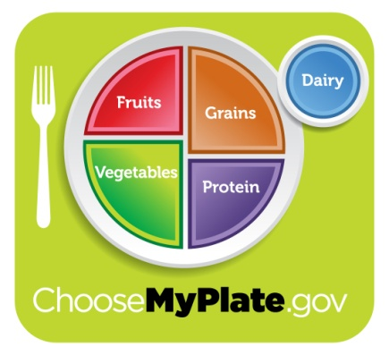
MYPLATE STUDY GUIDE
Name:__________________________________
Period:________

All Food Groups Are Needed
- Each food group __________________________ of the nutrients you need.
- _________________________ or food group can provide ______________.
- Eating a ______________ ensures you get _______________________.
People have different caloric needs depending on
- ________________________
- ________________________
- ________________________
Characteristics of Healthy Eating Patterns
- Reading and understanding ________________________
- _____________________________
- Functions and caloric value of the _________________________.
Fruits Group
- Tip: Make _________________________ fruits and vegetables.
- Use fruits as _______________________________ or desserts.
- Choose _______________________ fruits more often than ____________.
Vegetables Group
- Tip: Make ____________________ fruits and vegetables.
- Choose _____________________________________ fruits and vegetables.
- Eat more ____________________________________________ vegetables.
- Tomatoes, sweet potatoes and ________________ in main and side dishes.
Grains Group
- Tip: Make at least _________ of your grains ____________________.
- Choose ______________________ cereals, breads, crackers, rice and pasta.
- Check the _____________________ on food packages to find whole grain foods.
Proteins Group
- Tip: ________________ your protein ___________________.
- Choose a variety of foods including _____________________ and peas, _____________, lean meats, ____________________________.
- Keep meat and poultry portions _____________________________.
- Try _________________________________________________. These methods do not add extra ____________.
Dairy Group
- Tip: Switch to _____________________ milk.
- Get your _____________________ foods.
- Low-fat or fat-free dairy products have the _______________________ and other essential nutrients ______________________________ and calories.

