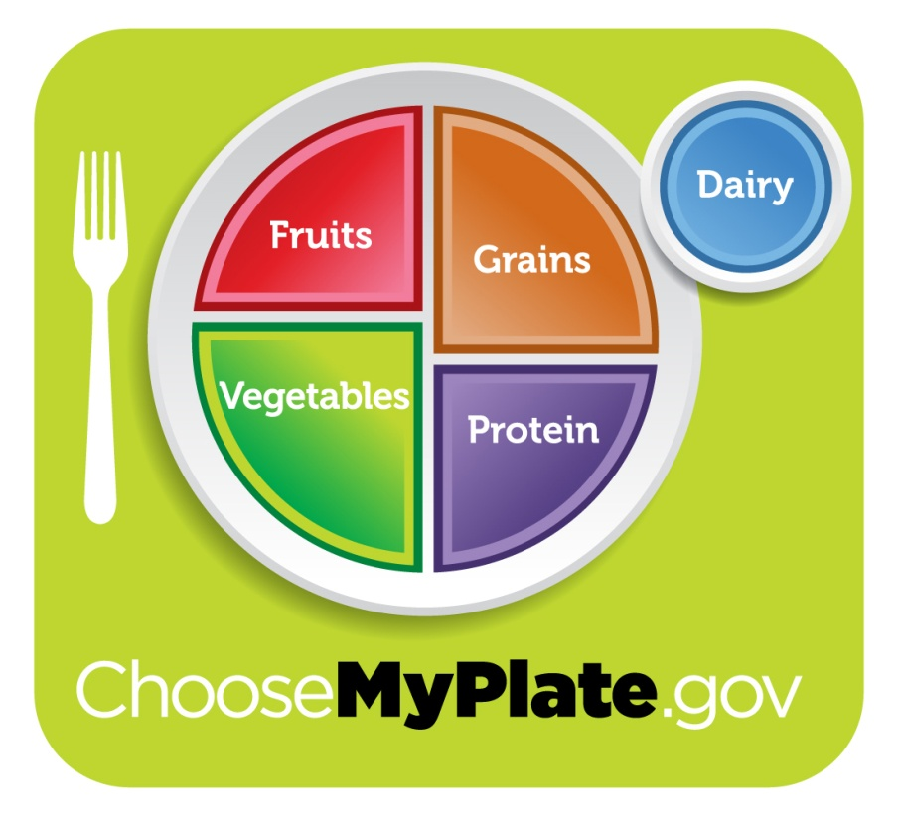
MYPLATE DIET EVALUATION
Performance Objective #9
Name:_______________________________
Period:______ Score: _____/100

- Go to https://www.supertracker.usda.gov
- Select, “Create Profile”. Create a profile by entering in your information. This allows you to save your work and analyze your data over time.
- Select the “Food Tracker” box.
- Enter all of the food and beverages (including water) you had for one entire day. Be very specific so you can really see how you are eating!
- Click the “Search” drop down arrow and that will allow you to narrow your search. Then, type the food you ate in the box to the right of the search box. Press enter or the “go” button. You will then be able to select exactly what you ate from a list of choices.
- You will then be asked to enter the amount by using their drop down menu.
- Also, choose the meal time you ate that food then press the “add” button.
- The computer will then automatically calculate what you have eaten and display the analysis in charts and numbers.
- Continue this process until you have entered all the foods you have eaten for the entire day.
- Click on the “My Reports” tab. Choose the “Food groups and calories” tab. Enter the date that you want to analyze (that is the date you entered all of your foods). Click “create report”. At the top right hand corner of the screen you will find the “export” command. Click on any format you would like: pdf, excel or word. Once in that format, print that report. You also have the option of saving the report and emailing it to the teacher at vmasters@americanleadership.net. Please state your name and class period in the body of the email.
- Do the exact same for the “Nutrients Report”.
- For the “Food Details Report”, select all for the “Food Groups and oils, Limits, and Nutrients”. Create the report, export and print as done previously.
****************************************************************
What to Turn In

- Type a one page paper on what these reports tell you. Include five paragraphs in your report:
  - Paragraph #1: Summary of personal dietary information.
    - How many calories you are allowed each day.
    - The personal recommended amount of fruits, vegetables, grains, proteins and dairy each day. (Will vary depending on age, gender and activity level)
  - Paragraph #2: Summary of your Food Groups & Calories Report
  - Paragraph #3: Summary of your Nutrients Report
  - Paragraph #4: Summary of your Food Details Report
  - Paragraph #5: Summary of this entire experience.
    - How well or not so well are you eating?
    - What can you do to change your eating habits (give specifics)?
    - Were you surprised with your findings?
    - Add any other relevant information you’d like.
  - The paper should be typed, 12 pt. font, 1” margins, correct grammar, and well thought out sentences.

- Turn in the following to the teacher (all stapled together please):
  - Your typed one-page paper (40 pts)
  - Food Groups and Calories Report (20 pts)
  - Nutrients Report (20 pts)
  - Food Details Report (20 pts)

****************************************************************

