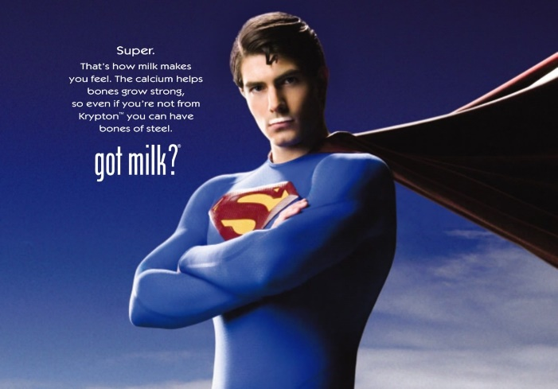
MEDIA INFLUENCES AND ROLE MODELS
STUDY GUIDE
Name: _________________________________
Period: ______

Reflective questions to ask yourself
- What affect does media have on _______________________?
- What role models do I have and how are they _____________________ me and __________________________?
Living in the Digital Age - The Good News
- Average ______________________ steadily ______________
- Higher ability to ___________ (shifting attention from one task to another)
- ______________ more __________________ to visual stimuli
- Improved ability to _________________ large amounts of ______________ rapidly and decide what’s important and what’s not.
- New uses of ______________________ that use different parts of the brain
- Increased ____________________________
Living in the Digital Age - The Bad News
- Lack of _______________________ and problem solving skills
- Loss of fundamental ____________________
- ________________ intimacy
- Shorter ________________________
- Impacts _________________________
- Loss of _____________________________
Communication through Media - Negative Effects
- ______________________ sexuality
- Increased _______________________ (cyberbullying, etc.)
- Increased _______________________________ activity
- ____________________ expectations
- Increased _____________________
- Information ____________________
Communication through Media - Positive Effects
- __________________________ world-wide
- Spreads _____________________
- _____________________________ on basic rights
- _________________________ (tutorials, etc.)
- ______________________ advertisements
- _____________________ programming
Psychology Today Magazine, Jan/Feb. 2009
“If you aren’t living according to your values, you won’t be happy, no matter how much you are achieving.”
How to Evaluate Media
- ____________________: Whose message is this?
- ____________________: What group is the target?
- ____________________: What do you actually see or hear?
- ____________________: What is the meaning we create from the text in our own minds?
- ____________________: What techniques are being used to persuade me to believe or do a certain thing?
- ____________________: What is the point of view the story is being told from?
What is a Role Model?
- A person who models _________________________, attitudes and values.
- Teens visualize they have the ability to be like that individual and ________ __________________ like them.
- Helps teens make decisions about his/her life in order to ____________________________________________
Choosing Role Models
- Role models can ________________ others’ personal _______________, attitudes and values-both positively and negatively.
- Successful people surround themselves with others who are ___________.
- We must be very careful whom we choose to be our __________________.
Top Qualities of Positive Role Models
- Passion and ability to ________________
- Clear set of ________________ they stick to
- Commitment to _________________________
- Selflessness and acceptance of ___________________
- Ability to ___________________________
Role Models and Goals
- Your mindset about _______________________ can have an influence on what role models you choose.
Growth Mindset
- Takes on challenges without _______________
- ______________________ during tough times
- Learns from ____________________
- __________________ feedback/criticism
- Seeks learning, ______________________- and success
Fixed Mindset
- Avoids or fears ____________________
- ______________________ when things are tough
- Makes _____________________
- _________________________ so failure isn’t possible
- No personal ____________________

“Those with whom we associate have an influence on us. Association with productive, self-sufficient, well-adjusted, happy people can have a positive effect on us that may lead to our success in life!”
YOU ATTRACT WHAT YOU ARE!!!

