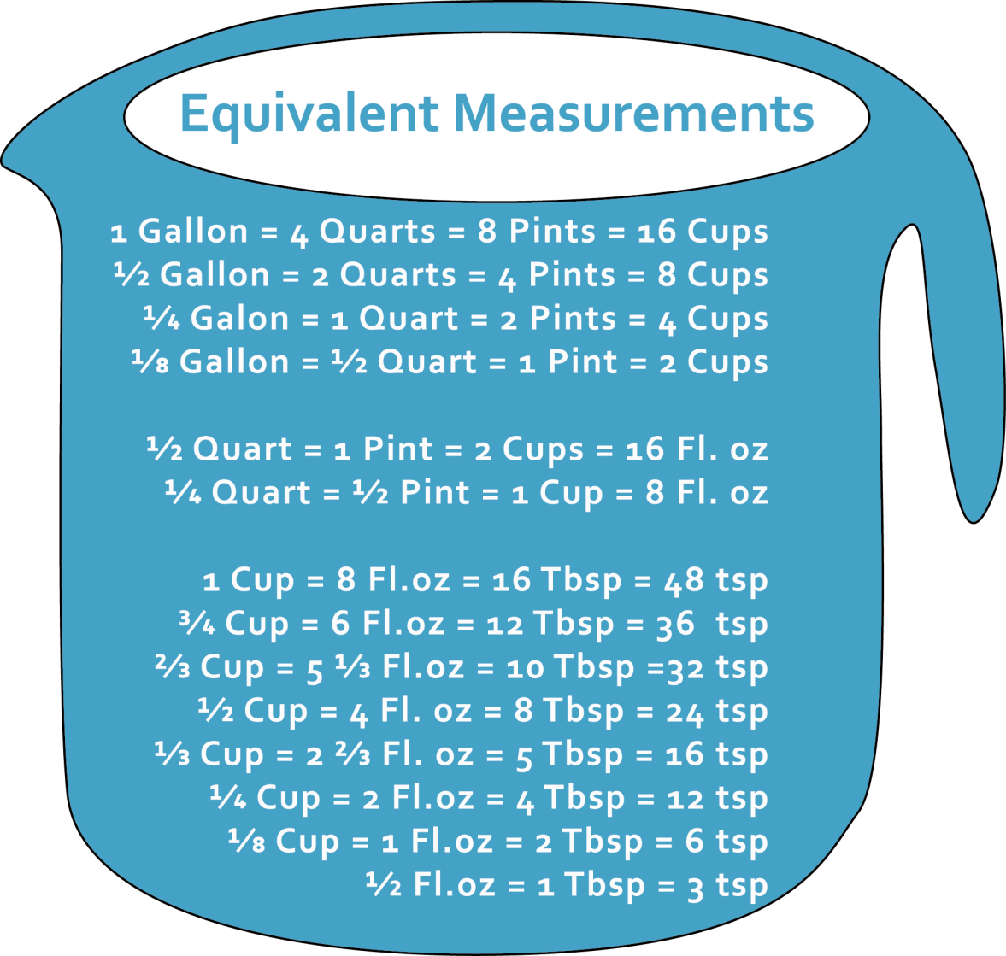

**RESOURCE FOR:** Cooking Terms and Measuring  
Equivalent Measurements

Measuring in the Kitchen

