KITCHEN MATH,
EQUIVALENTS AND
ABBREVIATIONS

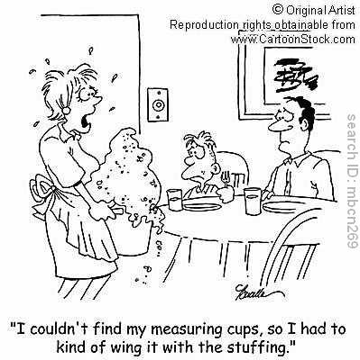

Name:_______________________
Period:____
- Know the proper order of measurements
Cups:
(smallest)_____ _____ _____ _____ _____ _____ (largest)

Measuring Spoons:
(smallest)_____ _____ _____ _____ _____ ____ ____(largest)

- Know the following abbreviations

Gallon:___________

Pint:_____________

Pound:_______ or _______

Hour:______

Teaspoon:_______ or _______

Quart:___________

Cup:____________

Ounce:__________

Minute:_________

Tablespoon: _____ or _____ or_____

- Gallon Equivalents

- Cup Equivalents

- Know the following equivalents:

3 tsp. = ____ Tbsp.

4 qt. = ____ gal.

2 c. = ____ pt.

4 Tbsp. = ____ c.

16 c. = ____ gal.

1 stick butter = ____ c.

16 Tbsp. = ____ c.

8 fl. oz. = ____ c.

16 oz. = ____ lb.

RECIPE RACE

For the recipe below, change the measurements so that the recipe is doubled and then change the measurements so the recipe is halved. The team done first and with the correct changes wins!

DOUBLED INGREDIENTS HALVED

__________ 2/3 cup shortening __________

__________ 2/3 cup butter __________

__________ 1 cup sugar __________

__________ 1 cup brown sugar __________

__________ 2 eggs __________

__________ 3 cups flour __________

__________ 1/4 tsp. baking soda __________

__________ 1/4 tsp. salt __________

__________ 12 oz. chocolate chips __________

__________ 1/2 cup nuts __________

KITCHEN EQUIVALENTS BINGO
Directions: Place the answers below into each of the boxes on your bingo card. Place each answer into a different box from your classmates so as not to have the same bingo card. No Free Spaces!!
Answers:

8 c.
1 c.
3/4 c.
1/2 c.
1/4 c.
1 gal.
1/2 gal.
16 oz.
1 pt.
2 pt.
4 pt.
1 Tbsp.
8 Tbsp.
16 Tbsp.
1 qt.
4 qt.

