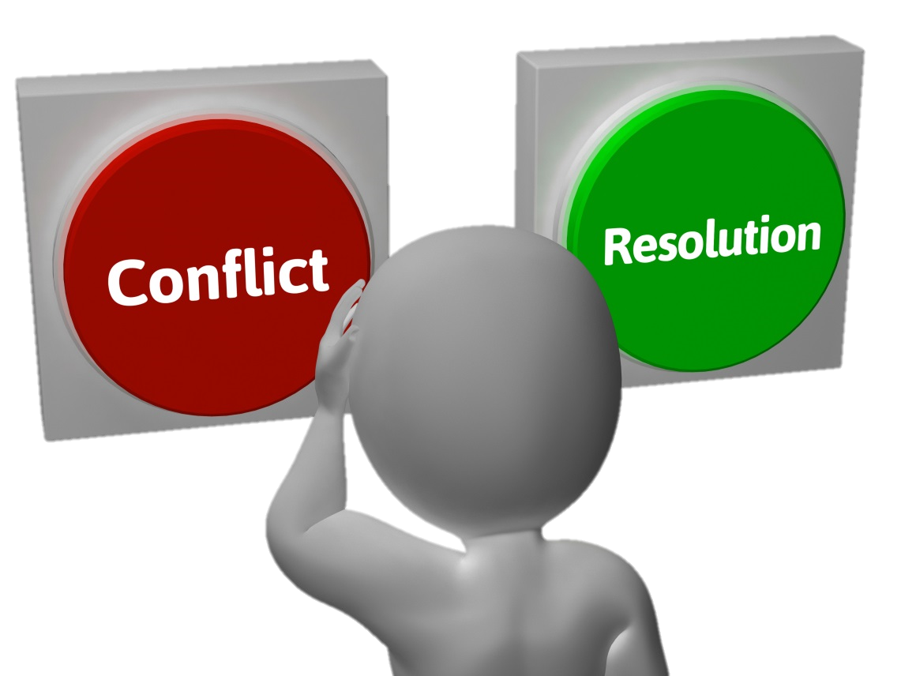
I-MESSAGES AND CONFLICT RESOLUTION
STUDY GUIDE
Name: _____________________________________
Period: _____
What are “I” Messages?
- “I” Messages are a helpful way of __________________________ and why you feel that way ________________________________ of your emotions.
- They allow you to ________________________ without others feeling _________________________________.
- They do take ______________________ to use effectively.
- There are _____________________ of an “I” Message….
Parts of an “I” Message
- I feel... (______________________________________)
- When you... (______________________________________)
- Because… (______________________________________)
- What I need... (______________________________________)
Examples of “I” Messages
- ______________ frustrated ______________ interrupt me _____________ I’m trying to talk. ________________________ is for you to listen.
- ______________ worried _______________ don’t call home ____________ I don’t know where you are. ____________________ is for you to call if you’re going to be late.
- _______________ happy _______________ share your emotions ____________ then I know how you’re really feeling. _________________ is for you to do that more often.
- _____________ upset _______________ copy my homework _____________ it took me a long time. ___________________ is for you to do your own work.

Conflict Resolution
- A conflict is a ________________________________ or misunderstanding.
- There are 3 types of Conflict Styles or Behaviors:
  - ____________________________
  - ____________________________
  - ____________________________
Avoidance
- This style tries to ______________________ all together rather than face it.
- ___________________ the subject
- “____________________” to avoid confrontation
- Avoiding the issue in _________________________________
- Communicating through the “_________________________”
Confrontation
- This style is ________________and sometimes hostile.
- “_________________ or the highway”
- Very _______________________ and competitive
- Used to _____________________ and control
- “____________” Messages
- Can _________________relationships
Problem Solving
- This style shows a _______________________________ to solve the problem positively.
- Uses ________________________to solve the problem
- ___________________ Attitude
- _____________________ communication
- “_____” Messages
Positive Conflict Resolution Skills
- Try to stay ________________________________
- Be aware of your ________________________________
- Use active listening skills to _________________________
- Focus on _______________________ instead of winning
- Ask ________________________
- Use appropriate body language / ________________________________
- Use ________________________________
- ______________________ about what is bothering you
Active Listening Skills
- Pay _________________________
- Look at the speaker / ______________________
- _______________ other tasks and listen.
- Listen with appropriate ______________________________
- Give ________________________ that show you are listening.
- Don’t _______________________
- Don’t __________________________ to your own problems.
- Don’t let your __________________________________
- Don’t _____________ the conversation.
- Put the ______________________________!

