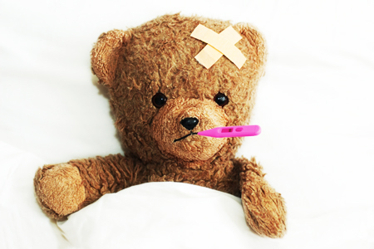
Health, Wellness and Safety Study Guide
Name: ____________________________________
Period:_____

Signs and Symptoms of Illnesses
- _______________________________
- Lack of __________________________
- Difficulty ___________________________
- Persistent ________________________
- Severe _________________________________
- Prolonged __________________________
- ____________________________
- ____________________________
- Anything else that is ________________________ of the child

Childhood Immunizations
- Communicable diseases
  - Diseases that can be _______________________________________
  - Example: _________________________
  - ________________________can prevent and protect from communicable diseases
- The child is given a _____________________ (shot or other form) of a ___________________________ small amount of the disease.
- The body then will _____________________________________ to it.
- Usually given at the age of ________________________ years old.
- Childcare centers, _________________, and ______________________ require children to be caught up on their immunizations ____________________________________________.

Side Effects of Immunization
- _________________________________
- _________________________________
- _________________________________
- _________________________________
- Swollen in the _____________________________________

Types of Immunizations
- ____________– Measles, Mumps, Rubella
- ____________– Diphtheria, Tetanus, Pertussis
- ____________– H. influenza type B
- ____________
- ____________ (Chicken Pox)
- ____________
- _____________________
- _____________________
- _____________________(flu) shot every year
- ____________________ – Every ten years

Basic First Aid Practices
- ____________________________________
  - ______________________ for about 10 minutes.
  - ______________________
- _____________________________________
  - Place burn under ______________________________
  - __________________________ ointment or lotion
  - Keep it ________________________________
  - ____________________________ the blister
- ______________________________________
  - Apply __________________________________
  - _______________ the wound
  - Apply a ______________________________
  - Cover with ___________________________
- ___________________________________
  - Sit or stand, leaning _____________________________
  - ________________________ to the lower part of the nose by squeezing for about 10 minutes.
  - _________________________ to see if the bleeding has stopped.
  - _______________________if necessary.
- __________________________________
  - Call ______________________________
  - They will ___________________________you as what to do
- _________________________________
  - If the child is ____________________, encourage them to continue.
  - ________________________ a coughing person on the back.
  - If they are not making any sounds or breathing, _________________ are needed.
- ______________________________________________________
  - Wash with ______________________________
  - Apply __________________________________.
  - If it breaks the skin, watch the site for _________________________.
- ______________________________________________________
  - Wash the area with _____________________________
  - _________________________________ or any other foreign object.
  - Apply _____________________ to area.
  - Cover with __________________________.
  - Watch the person and area for any ________________________ or infections.

Car Seats
- Know ____________________________ and car seat laws concerning children of all ages.
- Children _________________ should not sit in a seat where there is an __________________.
- The _______________ place for a car seat is in the _________________________________ of the vehicle.
Car Safety
- ____________________________________________ no matter what age.
- Older children can _____________ and not being able to get out of the car.

Child-Proofing Strategies
- Childproofing the house:
  - The child is _______________________________________________
  - The child has ______________________________ without risk of encountering hazardous objects and materials.
  - Best done ____________________________ learns to first ________________________________(roll, creep and crawl).
- Keep children away from:
  - ________________________
  - ________________________
  - ________________________
  - ________________________
  - Anything that could cause ________________________
- _____________________________ in the house should be set to ________________________________ Fahrenheit.
- Place all poisonous substances and medications ______________________
___________________
- Keep floors and stairs _____________________________ to prevent falls.
- Use _______________________________ on stairs.
- Place caps over all _________________________________.
- Place cords ____________________________________.
- _______________________________ not in use.
- Place ____________________________________ on all windows.
- Use ________________________________ with safety features.
- Keep _____________________________ away from children.

Toy Safety
- __________ appropriate
- Appropriate for the _________________________________
- Engage ___________________________ as possible at one time
- Have multiple _______________________________.
- _____________________________ paint
- ___________________ construction
- _________________________________
- ________________________________ broken toys
- ______________________________ should avoid toys that are small or __________________________ that can be swallowed and _____________________________.
- If it fits in a ___________________________, it is too small for them.
- Purchase washable toys and _________________________________.

