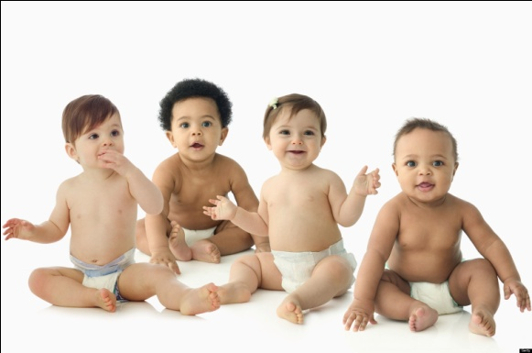
GENETICS AND HEREDITY STUDY GUIDE
Name:_______________________________
Period:_____

Genetics and Heredity
- Define Genetics: ________________________________________________
_____________________________________________________________
- Define Heredity: ________________________________________________
_____________________________________________________________
- What factors are determined by heredity? __________________________
_____________________________________________________________

Sex Cells
- Female Sex Cell
  - ________________________________________________________
  - ________________________________________________________
- Male Sex Cell
  - ________________________________________________________
  - ________________________________________________________

Chromosomes
- Rod shaped chemical compounds that _____________________________.
- The genetic coding transmits _____________________________________.
- Found in both _________________________________________________.
- Each mature sperm and egg cell contains ______________________ of chromosomes, ______________________.

Genes
- Define genes: _________________________________________________
_____________________________________________________________.
- Define trait: ___________________________________________________.
- There are ___________________________________ on each chromosome.
- They are the ____________________________________ of chromosomes.
- They can be ___________________________________________________.
Dominant Genes
- _____________________________________________________________.
- ______________________________ to pass on the characteristic.
- _____________________________________________________________.
Recessive Genes
- _____________________________________________________________
- ______________________ to pass on the characteristic.
- Will only produce a trait when it is transmitted by _____________________
_____________________________________________________________

Gene Example
- _____ = Brown eyes (dominate gene)
- _____ = Blue eyes (recessive gene)
- _____ = Brown eyes
- _____ = Blue eyes
- _____ = Brown eyes, but carries the recessive blue eye gene

Gender of a Child
- ___________________________________________ determine the gender.
- An ____________combination will produce a ________________________.
- An ____________ combination will produce a _______________________.
- The _____________________determines the sex of the child.

