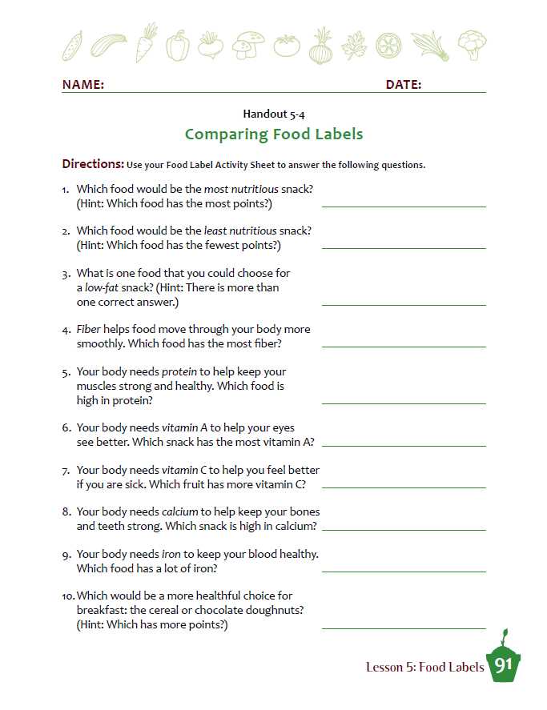

**Name:_______________­­­­­___________ Period:_____ Score:_____/20**

