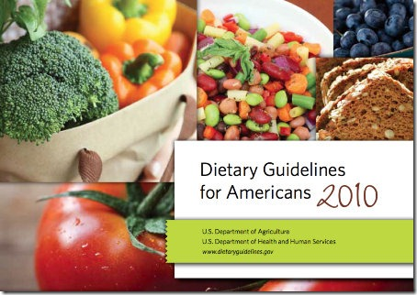
DIETARY GUIDELINES FOR AMERICANS
STUDY GUIDE

Name:______________________________________
Period:____

- Dietary Guideline # 1: __________________________________________
  - Two types of foods to choose from:
    - _________________________________________
    - _________________________________________
  - What are nutrient dense foods?
    - Provides ________________, ______________ and other beneficial substances with relatively ________ ___________.
    - Examples: __________________________________________
  - What are empty calorie foods?
    - Foods low or ______________ in ______________ but ___________in ________________.
    - Examples: __________________________________________

- Dietary Guideline # 2: ___________________________________________
  - Monitor ___________ and ____________ intake, ________________ ________________ and body ________________.
  - Reduce ____________________sizes.
  - When eating ____________, make _______________ choices.
  - Limit ____________________ time.

- Dietary Guideline # 3: __________________________________________
_____________________________________________________________
  - The Average American Diet:
    - Has more __________, sodium, ___________ and calories than recommended.
    - Are _____________ in ____________ and ___________ ____________ than recommended.
  - Facts about salt and sodium:
    - Salt and sodium are usually added to processed ____________ and __________________and ___________ drinks.
    - High consumption of salt and sodium are contributing factors to ____________ _______________ ________________.
    - How much sodium should you have per day? ______________

- Dietary Guideline # 4: __________________________________________
_____________________________________________________________
  - Recommendations for fruits and vegetables:
    - Make half your plate _________and _____________________.
  - Recommendations for whole grains:
    - Make at least half your grains _____________ grains.
  - Recommendations for milk:
    - Switch to _____________ or ______________ (1%) milk.
  - Recommendations for seafood:
    - Eat two ______________ servings (or one _______________ serving) a week of seafood.
    - Choose ____________ products in place of some ________________.
  - Recommendations for oils:
    - Use ___________ in place of ______________ _________.

- Dietary Guideline # 5: __________________________________________
_____________________________________________________________

- Dietary Guideline # 6: __________________________________________
_____________________________________________________________
  - Adults should exercise _________________ a day
  - Children/Teens should exercise _________________ a day

