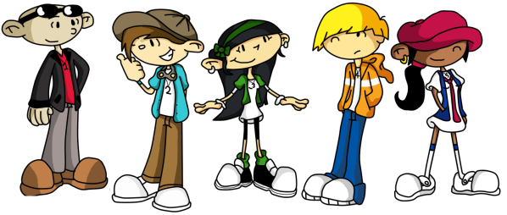
DEVELOPMENTAL TASKS STUDY GUIDE
Name:________________________________ Period:______

What are developmental tasks?_________________________________________
___________________________________________________________________
___________________________________________________________________
Developmental Task #1:_______________________________________________
___________________________________________________________________
___________________________________________________________________
Developmental Task #2:_______________________________________________
___________________________________________________________________
___________________________________________________________________
Developmental Task #3:_______________________________________________
___________________________________________________________________
___________________________________________________________________
Developmental Task #4:_______________________________________________
___________________________________________________________________
___________________________________________________________________
Developmental Task #5:_______________________________________________
___________________________________________________________________
___________________________________________________________________
Developmental Task #6:_______________________________________________
___________________________________________________________________
___________________________________________________________________
Developmental Task #7:_______________________________________________
___________________________________________________________________
___________________________________________________________________
Developmental Task #8:_______________________________________________
___________________________________________________________________
___________________________________________________________________
How can knowing who you are and what you want out of life help you meet the developmental tasks?_________________________________________________
___________________________________________________________________
___________________________________________________________________
___________________________________________________________________

