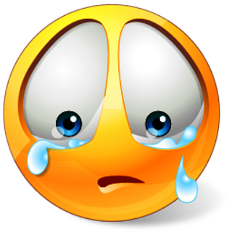
DATING VIOLENCE STUDY GUIDE
Name: _____________________________
Period: ______
Sexual Harassment
- Any _______________________ or communication of a _______________ that ___________________________ a person’s relationship, employment opportunities or environment.
- Harassment may be _____________________________.
Examples of Sexual Harassment
- ________________________________________
- ________________________________________
- ________________________________________
- ________________________________________
- ________________________________________
- ________________________________________
- ________________________________________
- ________________________________________
- ________________________________________
- ________________________________________
- ________________________________________
- ________________________________________

Dealing with Sexual Harassment
- Let the person know that you are __________________________________
- _______________________________ and be assertive.
- ______________________: Parent, relative, coach, teacher, counselor, etc.
- ___________________ of the harassment to show what’s been happening.
- If you see or suspect something, __________________________!

Types of Abuse
- _______________________
  - Can begin with ______________________________
  - ______________________ fist through wall
  - Escalated to pushing, __________________, restraining, etc.
  - Finally, it can become ______________________________
- _______________________
  - Any _________________________________, forced sexual behavior.
  - It may escalate to ___________________________________.
- ________________________________
  - Constant _________________________ and abuse
  - ___________________________
  - Excessive _________________________
  - __________________________________ from others
  - Damage of _____________________________
  - ________________________
What is Dating Violence?
- A pattern of behavior used to establish ___________________________ over another person through ________________________________.
- Often including the _____________________________.
- It occurs when one person believes they are _________________________
_________________________________
- Those involved are in an ______________________________________.
Warning Signs of a Violent Partner
- Wants to get __________________________.
- ______________________________ for an answer.
- Is overly _________________________________.
- ________________________________ their partners friends and activities.
- Is ______________________________. They make all of the decisions.
- _________________________________ when alone or in front of others.
- Makes _________________________, “if you really love me you would…”
- _________________________ for behavior, “It’s because of you that I get so angry!”
- ______________________________________, “I’ll never do it again, I promise.”
- Has strong ideas about _________________________.
Why Teens Stay in Abusive Relationships
- _________________________ or ashamed
- __________________________________ if they try to end the relationship
- Convinced it’s ___________________________
- ___________________________ with healthy dating relationships
- __________________________________ with love
- _____________________________ (don’t know their being abused)
- Afraid friends and family _________________________________
- Feel like there is __________________________________ for support
- Mix of “good times” and ____________________________________
- Believe that ________________________________ is the MOST important thing in their life (Better to be with someone than alone)
Abusive Relationship? What to do
- Realize that it is ____________________________.
- Realize that this type of behavior is ___________________________!
- _________________________ – ANYONE!
  - Parents or ___________________
  - Trusted adult or ____________________
  - School ______________________ or police
  - __________________________ mental health worker

