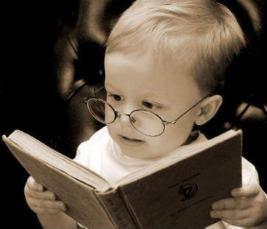
COGNITIVE DEVELOPMENT OF AN INFANT
STUDY GUIDE
Name:__________________________________
Period:_____

Piaget’s Sensorimotor Stages
- Lasts from _____________ to about _______________
- Babies ___________through their __________ and their own __________.
- _____________________ is vital to brain development and fostering ___________________________.
- Babies put things in their _________________to learn through their senses.
- Acts _____________________to produce __________________
- Begins to _____________________________
- _____________________others
- ________________________________________
- Begins ________________________________
Object Permanence
- Knowing that an _________________ even when it is _________________.
Language Development
- Begins with ___________________
- Then ______________________
- _____________________________
- ___________________________
- Putting a ________________________________________
Parentese
- The intentionally _______________nonstandard _____________ of speech.
- _______________of young children ___________________________
- Used by adults in _______________________________________.
- Often accompanied by __________________________________________.
Why Speak Parentese?
- Helps parents and caregivers ______________________________
- Infants actually _____________________ to adult conversations. They will ______________________ to hear it.
- Babies not only enjoy the _______________________, they also like _________________________ as we talk to them.
- ______________ uses __________________________________________
- _________________ uses _________________, in short and simple _________________, often _________________ over and over again
- The ___________________, high pitch, exaggerated facial expressions and short, simple sentences actually __________________________________.
- Their brains are “_____________________ they are hearing, and talking in a way that _________________ helps them ____________________ and understand language.
- We tend to ________________________________ when we talk to babies
- Pulling out the ___________________ and clearly ____________________
- In marked contrast to the ___________________ to other ____________.
Importance of Literacy
- Begin reading to a child _________________________ and make it part of the _____________________.
- Children should be read to _________________________________.
- _______________________ while you are reading to them.
- Reading together _______________________________________.
- Children’s books _____________________________ to be educational.
- Reading to a child is one of the best ways to _________________________
____________________________________________________________
- Encourage an interest in books and reading by choosing books that _______________________________________. _____________________ enhance a child’s cognitive skills.
- Books help a child learn to _______________________________________.
- It is one of the best ways to help __________________________________.
- Books are a great way to _________________________________________ (death, divorce, fears, etc.)
- ___________________ is a learning disability in which the child uses ________________________________________________

