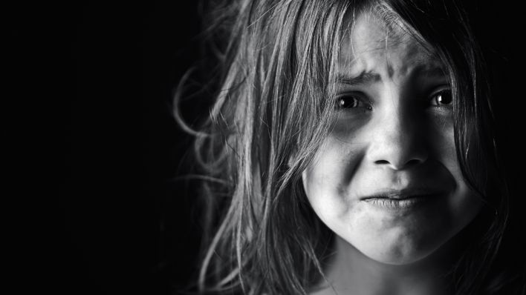
Challenging Situations Study Guide
Name:____________________________
Period:______

Challenging Situations = Stress
- Challenging situations cause __________ in a child’s life.
- Stress results from __________________________________, good or bad.
- Examples: Handicaps, _______________, starting school, grief, _________, divorce, illness or _________________.

Signs of Stress
- ____________________________________
- ____________________________________
- ____________________________________
- ____________________________________
- ____________________________________
- ____________________________________
- ____________________________________

Childhood Feelings
- Children usually ________________________ what is going on.
- Tell children _________________ in a calm and reassuring way. No need to include __________________, but enough.
- Allow children to _______________________________________.
- Children _____________________ and support through issues than adults.
- Support may need to come from an adult that is ______________________ in the stressful situation.

Coping Strategies for Children
- Daily exercise or ______________________
- Eating _______________________
- Having ___________________________
- Enjoying _________________________
- Adequate ____________________
- _______________________methods
- Talking about ________________________

Children Grieving
- Grieving is not just for __________________________________.
- Children can go through the stages of grief for _______________________.
- Examples:
  - Lost blanket or ________________________
  - ________________________to a new house
  - _____________________of parents

Stages of Grieving
- _______________ : Feelings of shock
- _______________: Blame someone or something for what they did to cause this.
- _______________: Blame oneself for something they did in the last few months to cause this.
- _______________: With other people or with God to not let it happen
- _______________: Coming to terms, moving on, adjusting to the change.

Knowing Ahead of Time
- Children _____________________ in actions and the tension associated with the situation.
- Tell the children about the situation so they have _____________________ to the events it will bring.
- Examples: Financial challenges, ____________________, Moving situations

Divorce
- Reassure the child that they are ___________________________________.
- The child should _________________________ for the divorce.
- Maintain as much _________________ in the child’s life as possible. (same school, same home, same routines, etc.)
- Provide ____________________ in the child’s daily schedule and situation.
- Children ________________ that their parents will get back together again.
- Parents should never _________________ one another in front of the kids.

Effects of Divorce on Children
- _________________________ (ages 2-5 years old)
  - Major Theme: ____________________________________________
  - Symptoms: ______________________________________________
  - What to do: Explain that custodial parent will ___________________
- _________________________ (ages 5-9 years old)
  - Major Theme: ____________________________________________
  - Symptoms: ______________________________________________
  - What to do: ______________________________________________
- __________________________ (ages 12-18 years old)
  - Major Theme: Fear of ______________________________________
  - Symptoms: ______________________________________________
  - What to do: _____________________________________________

Death
- Children dealing with death feel grief and ___________________________.
- Help children understand that they will not die _______________________ has.
- Reassure children by _________________________ about when you will return whenever you leave.
- __________________________________ before the child is confronted with the death of a loved one.
- Under the age of 3
  - Children think of death as if the person has gone on a ___________________________.
  - Believe that __________________________________.
  - Death does __________________________________ to them.

Effects of Death on Children
- ______________________________ (ages 2-5 years old)
  - Think it’s ________________________and that the person comes back (video game mentality).
  - Think little _______________________________.
  - ________________________(they caused it).
  - Don’t understand ________________________.
  - Fear of ______________________________.
- _______________________________ (ages 6-12 years old)
  - Understand physical _______________________ (gun, attack, illness)
  - Think that death is ____________________________
  - Think death is only for _____________________ and careless people
  - Still ________________________ (won’t happen to me)
  - Intrigued by ______________________________________
- ________________________________ (ages 12-18 years old)
  - Natural for ____________________________
  - Death results in bodily ______________________________
  - Feelings of _________________________ (it won’t happen to me)
  - _________________________being old or sick and dying
  - Develops _______________________________ about death

Fears
- ____________________________ of the child and do not belittle the child over them.
- Children tend to be _________________________ between the ages of _______________________
- They have an ___________________________ and cannot yet discriminate between real and unreal dangers.
- Help the child _______________________________________
- Be understanding and ____________________________________

Overcoming Fears
- Using the following techniques will allow the child to deal with and talk about fears more freely:
  - _______________________________. Act out the fearful situations.
  - __________________________ of the fear.

Abuse
- Child abuse is anything that intentionally is _________________________ or harm a child.
- Most child abuse is done by people the child ________________________.

Why Does Abuse Happen?
- The _________________________ as a child and so they are just ________________________what was done to them.
- The adult ____________________________ of any other methods for discipline or having a knowledge of appropriate ______________________.
- The adult is stressed and has reached their __________________________ so they take this out on the child.
- Children with physical and mental ________________________ are at risk for abuse.
- _______________, parents, ________________________, single parents, parents involved in alcohol and drugs, and parents ____________________ are more likely to be _____________________.

Emotional and Verbal Abuse
- ________________________ children
- ________________________ them
- Blaming them or _______________________________ them, particularly for problems beyond their control

Physical Abuse
- ________________________ causing injury to a child.
- ____________________________________
- ____________________________________
- ____________________________________
- ____________________________________

Sexual Abuse
- Includes any _________________________ sexual behavior with a child
- ___________________________
- Taking ________________________________
- Inappropriate _______________________________

Neglect Abuse
- Failing to provide for a child’s _____________________________
- Can be both _____________________________________
- Examples include: food, _____________, shelter, ________________, love, ____________________and medical.

Reporting Abuse
- Utah is a ___________________________.
- It is required by law to _______________________________.
- All reports are kept _______________________________.

Where to Find Help?
- To report child abuse, contact:
  - ________________________________ services
  - ________________ (Department for children, schools and families)
  - Local _________________________________________

