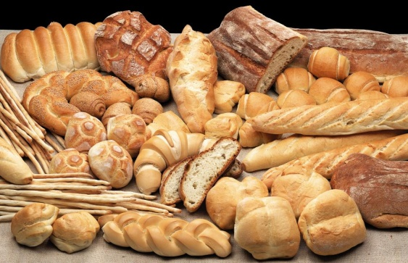
CARBOHYDRATES AND FIBER STUDY GUIDE
Name:________________________________
Period:_______
- What is a Carbohydrate?
  - Carbohydrates are the main ________________found in the ____________ group.
  - Carbohydrates can be found in ____________ quantities from the other ____________ ______________.
  - Carbohydrates should be ______________% of our daily food intake.
  - The primary function of carbohydrates is to ___________________.

- Caloric Content of Carbohydrates
  - Carbohydrates provide _____ calories per gram.
  - A ______________ is the unit used to measure the _____________ ________________ of foods.
  - So, for each ______________ of carbohydrate you eat, you are given _____________units of _____________________.

- Types of Carbohydrates
  - _______________ Carbohydrates
    - Also called ____________________
  - _______________ Carbohydrates
    - Also called ____________________
  - _______________
    - Also called _______________ or _________________
    - A form of a __________________________________

- Functions of Carbohydrates
  - Simple Carbohydrates
    - Provides a ______________energy source.
  - Complex Carbohydrates
    - Provides a ___________ ______________, continuous energy source.
  - Fiber
    - Attracts _____________ to our ______________and _____________food through the intestines faster.
    - Helps to keep _____________movements ______________ in form and reduces problems related to ___________________.

- Foods Sources of Simple Carbohydrates
  - ___________________________
    - _________________ sugar
  - __________________________
    - _________________ sugar
  - __________________________
    - _________________ sugar
  - __________________________
    - _________________ sugar
  - __________________________
    - _________________sugar

- Food Sources of Complex Carbohydrates
  - _____________________grains
  - __________________ products
  - Dried ____________________
  - _________________________
  - _________________________

- Parts of a Wheat Kernel
  - _________________________
    - Nutrients Provided
      - __________________________
      - __________________________
  - _________________________
(#7 - Parts of a Wheat Kernel continued)
    - Nutrients Provided:
      - Unsaturated _______________ _______________
      - __________________________
      - __________________________
      - __________________________
      - __________________________
      - Other ___________________ ____________________

  - ____________________________
    - Nutrients Provided:
      - _____________________________
      - _____________________________
      - _____________________________

- Food Sources of Fiber
  - ________________ and ______________________
    - Especially the ________________or ___________________
  - Whole _____________________
  - ___________________________
  - ____________________ Cereals
  - Dry _____________________
  - ________________________
  - Split ___________________
  - _______________________

- Digestive Process of Simple and Complex Carbohydrates
  - Simple Carbohydrates
    - Digested ____________and _______________ by the body.
  - Complex carbohydrates
    - ____________ down into _____________ sugars for an _______________digestive process.

- Digestive Process of Fiber
  - ____________________ is a non-digestible fiber.
    - Which means the body does not _____________ or ____________fiber.
    - It passes right through your body like a bull dozer, __________ the ___________ as it goes.
  - ______________ plenty of _______________ is key for a ______________digestive process.

- Fiber and Water
  - In the small and large intestines, ____________ attracts ____________ just like a dry sponge soaking up water.
  - When fiber acts like a sponge, the amount of material in the intestine is ___________________.
  - Therefore, fiber creates _____________ in the diet.
  - You are going to feel ___________longer.
  - The ____________ ___________ mixture of fiber and water help ____________food through the intestines.
  - _________fiber diets do __________ attract ________________.
  - Without the presence of fiber and water in the intestines, the digested food mixture becomes ____________, hard or stale – you become ____________________!

- Daily Recommendations for Carbohydrates and Fiber
  - Make ____________ your grain intake _____________ grains.
  - The National Cancer Institute recommends ________________ grams of daily fiber.
  - Fiber may reduce the risks of _____________________, ____________and ______________cancer.

