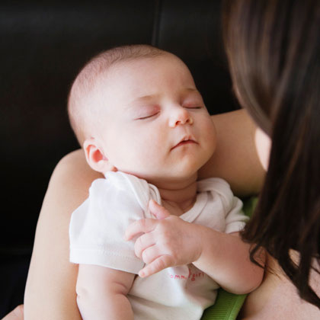
BIRTH DEFECTS STUDY GUIDE
Name:_____________________________________________
Period:_______
Birth Defects
- An ________________ that affects the _____________________________ of the body.
- ______________ is born with some type of ________________ (birthmark for example).
- Birth defects are children born with __________________________________________.
Causes of Birth Defects
- Heredity
  - __________________________________________________________________
- Environment
  - __________________________________________________________________
- A combination of both ____________________________________________________.
Environmental Influences
- Harmful substances taken by the mother
  - _________________________________________
  - _________________________________________
  - _________________________________________
  - _________________________________________
  - _________________________________________
- When the mother consumes harmful substances, the following can happen to the fetus:
  - ______________ the fetal ____________________
  - Cause __________________________________________ babies
  - Varying levels of ___________________________________
  - _________________________________
- Diseases or Infections from the mother

  - ________________________
  - ________________________
  - ________________________
  - ________________________
  - ________________________
  - ________________________
  - ________________________
  - ________________________
  - ________________________

Helping to Prevent Birth Defects
- Avoid exposure to ________________________________________________________.
- Get appropriate ______________ and follow _________________________ techniques.
- ____________ of the mother
  - Risk for ____________________ increase if the age of the mother is _________.
  - Example – _________________________________
- Seek _________________________________ medical attention/prenatal care.
  - Early = By the ________________________ of pregnancy
  - Continual = At least ______________ over the course of 40 weeks of pregnancy.
- Maintain a ________________________________.
  - The placenta does not transfer ________________________ to the fetus if a woman is _______________________________.
- ___________________________
  - _________________________________________________
- Appropriate ____________________________________
  - __________________________________ during pregnancy.
- Receive proper _________________________________ prior to becoming pregnant.
  - Receiving the ______________ may be _________ for women who are pregnant.
- Do not contract an ________________________________
  - Those infections are _____________________________________.

Folic Acid
- Helps to ________________________________________________________.
- Women of childbearing age who have _____________________________ intakes are more likely to give birth to babies with _______________________________.
- _____________ of folic acid _____from supplements or fortified foods is recommended.
- Neural tube _________________________ during the ________________ of pregnancy before a woman may realize she is pregnant.
- This may be prevented as a mother _____________________________ to conception.

Detecting Birth Defects
- _______________________________
  - Utilizes sound waves to detect the ___________________________ of the fetus.
- _______________________________
  - _________________________ through the abdominal wall and into the uterus and withdrawing some ___________________________ to detect birth defects.

Method of Inheritance
- Recessive Inheritance
  - _______________ in a pair must be ______________________ to cause disease.
  - People with only _____________________ in the pair are considered ________.
  - Examples include:
    - _____________________________________
    - _____________________________________
- Dominant Inheritance
  - The _____________________ gene is a ___________________ gene located on one of the nonsex chromosomes.
  - You need only ______________________ to be affected by this type of disorder.
  - Examples include:
    - _______________________________________
- Multi-Factorial Inheritance
  - Many factors are involved – ___________________________________________
  - ____________________of genes from both parents, in addition to unknown ______________________factors, produce the trait or condition.
  - Examples include:
    - _____________________________________
    - _____________________________________
    - _____________________________________
    - _____________________________________
    - _____________________________________

- Chromosomal Error
  - The fertilized egg cell contains chromosomes in an ________________________
__________________________________________________________________
  - Examples include:
    - ________________________________________
- Congenital Malformation
  - A condition that is _____________________________________________.
  - Examples include:
    - ________________________________________________
    - ________________________________________________
    - Extra __________________________ (such as a finger)
- Blood Disorder
  - Affect any of the ______________________ main components of blood
  - ___________________________________: Carry oxygen to the body’s tissues
  - ___________________________________: Fight infection
  - ___________________________________: Help blood to clot
  - Examples include:
    - _______________________________________________________
- Prenatal Damage
  - Exposure to ____________________ during critical prenatal development which _________________________________ to the embryo or fetus before birth.
  - Examples include:
    - _____________________________________________________
    - _____________________________________________________
- Metabolic Disorder
  - Genetic conditions that result in _______________________________________.
  - _____________________________: The chemical reactions taking place in the body to convert or use energy.
  - Major examples of metabolism include:
    - Breaking down the ___________________________________________ in food to release energy.
    - Transforming excess ___________________________________ excreted in urine
    - Breaking down or converting chemicals into other substances and ________________________them inside cells
  - Examples include:
    - _______________________________________
    - _______________________________________
- X-Linked (Sex-Linked)
  - Traits carried on the ________ chromosomes which makes ________________________ but the ____________________ show up in the _______________________.
  - Examples include:
    - ______________________________________
    - ______________________________________
    - ______________________________________

Influences on Birth Defects
- Heredity
  - ___________________________________
  - ___________________________________
  - ___________________________________
  - ___________________________________
  - ___________________________________
  - ___________________________________
- Environmental
  - ___________________________________
  - ___________________________________
- Combination of Heredity and Environmental
  - ____________________________________________
  - _____________________________________________
  - ____________________________________________
  - ____________________________________________

